**Project Name**

RAILWAY RESERVATIOIN SYSTEM

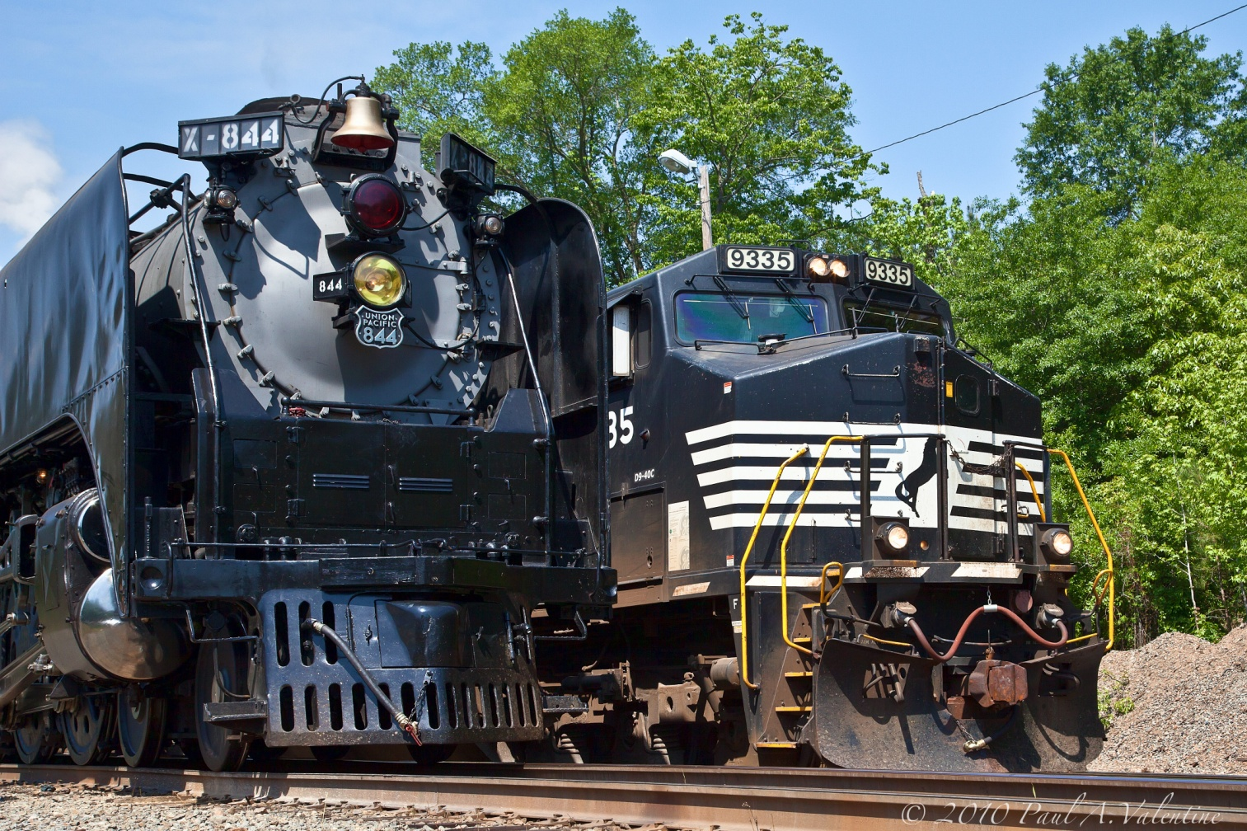

**Project Description**

This project will give us the information about railway reservation. This website “Railway Reservation System” facilitates the passengers to enquire about the trains available on the basis of source and destination, booking and cancellation of tickets, enquire about the status of the booked ticket, etc. Being more specific, this online railway reservation system can perform the basic function reservation and cancellation.

The customers are required to register on the server for booking tickets and for getting PNR information. This system also provides the information about trains and cancelled trains to the customers. The oldest method of tickets booking which was inefficient, time consuming and takes lot of efforts. So this system is required for reducing the time and effort of the customers.

**Existing System**

The present system is manual & complex. It is very time consuming lengthy & includes a lot of manual work. A record of the entire passenger has to be maintained manually (like name, age, passenger detail, agent record, etc). Updating the record of passenger is a Herculean task.

**Problems in the Existing System**

As everyone know that there is a big difference between Manual and a Computerized System. A Computer System is used for better performance in comparison to the Manual System or the Manual System is upgraded to Computer System due to various problems (like modification in the registers, wastage of time and space, wastage of stationary, etc.). Some problems present in the Existing Salary System are given below:

* It was very complex and time consuming.
* A lot of manual work has to be done.
* Separate registers and a record has to be maintained.
* Lot of calculations has to be done before generating the premium rate.
* It was very expensive and requires a lot of space to retain the records.
* It was very difficult for a newer agent to understand and to work immediately in the existing system.
* Complex for checking and record maintenance purposes.

**Problem Analysis**

* **Product Function:**

It tells the short note about the product.

* **Train Details:**

Customers may view the train timing at a date their name and number of tickets. For checking Train Details take the Train No or Train Name form the user, and check it is valid or not. If Not then display appropriate message to user else display the Train No, Train Name, Source, Destination, Arrival Time and Departure Time.

* **Reservation:**

After checking the number of seats available the customers reserve the tickets.

* **Cancellation:**

If the customers want to cancel the ticket, then half of the amount paid by the customer will be refunded to him. For Canceling Reservation OR Booking, it necessary that before 10days from journey date passenger can cancel ticket.

For Cancel Ticket take the PNR No from the User/Passenger, check PNR No is valid or not. If not valid then display appropriate message to user else display the details of that PNR No and ask sure user want to cancel ticket if yes then cancel the reservation of that PNR No.

* **Feasibility Analysis**
* **Train Routes:** This is a ternary relation that says that a train runs over a route using a particular scheme. The attributes in this include:

1. Fare for the train between the two stops given by the route specified.
2. Any scheme valid on this train, for this route
3. Number of booked seats on this train.

* **Train Route Ticket**: This ternary relation says that a ticket is booked on a certain train over one route that the train allows. It has only the primary keys of each entity.
* **Profile Ticket Relation**: This consists of two relations: user profile related to ticket and the official profile related to ticket. This is done to keep the user and official profiles separate and independent from each other.

**Project Requirement Analysis**

* **Introduction**

Requirements analysis is critical to the success of a development project. [Requirements](http://en.wikipedia.org/wiki/Requirement) must be documented, actionable, measurable, testable, related to identified business needs or opportunities, and defined to a level of detail sufficient for system design. Requirements can be [architectural](http://en.wikipedia.org/wiki/System_architecture), [structural](http://en.wikipedia.org/wiki/Structure), [behavioral](http://en.wikipedia.org/wiki/Behavior), [functional](http://en.wikipedia.org/wiki/Functional_requirements), and [non-functional](http://en.wikipedia.org/wiki/Non-functional_requirements).

* **General Description**

**Hypertext markup language (HTML**) is the major markup language used to display Web pages on the Internet. HTML is a text-based approach to describing how content contained within an HTML file is structured. This markup tells a web browser how to display the text, images and other forms of multimedia on a webpage.

**CSS** stands for **Cascading Style Sheets**. CSS describes how HTML elements are to be displayed on screen, paper, or in other media.CSS saves a lot of work. It can control the layout of multiple web pages all at once

**PHP Hypertext Preprocessor** is a general-purpose programming language originally designed for web development. PHP is a server side scripting language that is used to develop Static websites or Dynamic websites or Web applications. The client computers accessing the PHP scripts require a web browser only

* **Specific Requirements**
* **System**
  + Windows XP Service Pack 2 or above (for 2010 release, Service Pack 3)
  + Windows Server 2003 Service Pack 1 or above
  + Windows Server 2003 R2 or above
  + Windows Vista
  + Windows Server 2008
  + Windows 7,8,10
* **Software Requirement:**

Front End : Internet Explorer, Opera, Chrome etc

Back End : HTML, CSS, PHP

* **Hardware**
* **Minimum**:

1.6 GHz CPU, **1**024 MB RAM, 1024×768 display, 5400 RPM hard disk

* **Recommended:**

2.2 GHz or higher CPU, 2048 MB or more RAM, 1366×768 display, 7200 RPM or higher hard disk

**Design**

* **System Design :**

**Data Flow Diagram**

A **Data Flow Diagram** (or **DFD**) is a [graphical](https://www.computerhope.com/jargon/g/graphic.htm) representation of the flow of [data](https://www.computerhope.com/jargon/d/data.htm) through an information system. It shows how information is [input](https://www.computerhope.com/jargon/i/input.htm) to and [output](https://www.computerhope.com/jargon/o/output.htm) from the system, the sources and destinations of that information, and where that information is [stored](https://www.computerhope.com/jargon/s/stordevi.htm). Information not shown in a DFD includes how long processes take, and whether those processes operate in series or parallel. Such information is typically shown in a [flowchart](https://www.computerhope.com/jargon/f/flowchar.htm) instead.

**Why DFD?**

DFD graphically representing the functions, or processes, which capture, manipulate, store, and distribute data between a system and its environment and between components of a system. The visual representation makes it a good communication tool between User and System designer. Structure of DFD allows starting from a broad overview and expands it to a hierarchy of detailed diagrams. DFD has often been used due to the following reasons:

* Logical information flow of the system
* Determination of physical system construction requirements
* Simplicity of notation
* Establishment of manual and automated systems requirements

**DFD Symbols**

There are four basic symbols that are used to represent a data-flow diagram:

|  |  |  |
| --- | --- | --- |
| **Symbols Name** | **Symbols** | **Description** |
| **External Entity** |  | An external entity is a person, department, outside organization, or other information system that provides data to the system or receives outputs from the system. |
| Process |  | A process receives input data and produces output with a different content or form. Processes can be as simple as collecting input data and saving in the database. |
| Data Flow |  | A data-flow is a path for data to move from one part of the information system to another. |
| Data Store |  | A data store or data repository is used in a data-flow diagram to represent a situation when the system must retain data because one or more processes need to use the stored data in a later time. |

**DFD DIAGRAM**

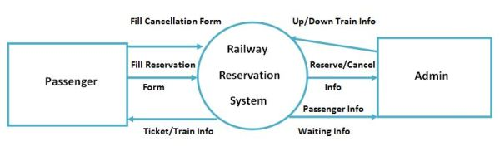

**Zero (‘0’) Level DFD – Railway Reservation system**

**Reservation Storage File**

**Passenger**

**Up Storage**

**Down Storage**

**1-Level DFD – Railway Reservation System**

**Reservation**

**Report**

**Reservation**

**Reservation**

**Passenger**

**Waiting**

**Generate Ticket**

**Cancel Ticket**

**Reservation**

**Waiting Table**

**Generate Report**

**2-Level DFD- Railway Reservation System**

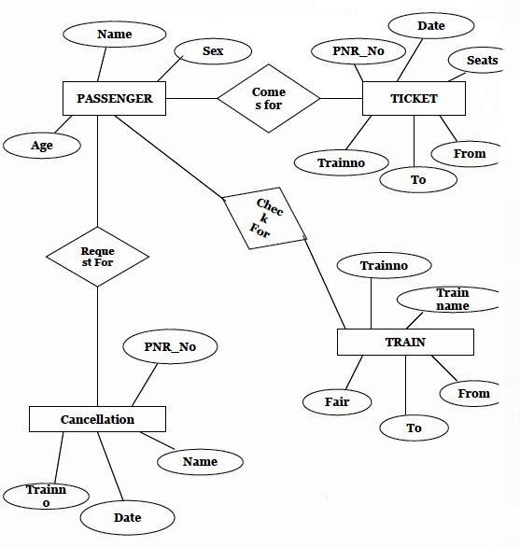

**ER Diagram - Railway Reservation System**

* **Detailed Design**

HOME

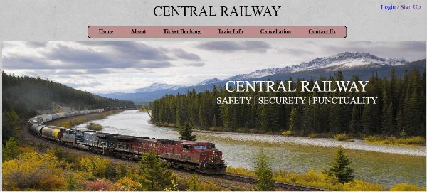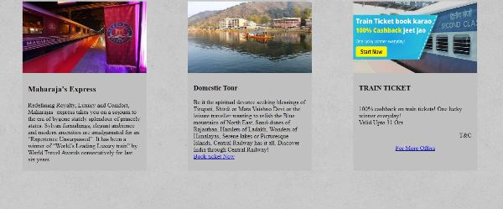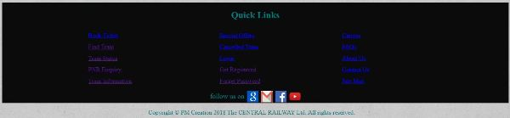

ABOUT US

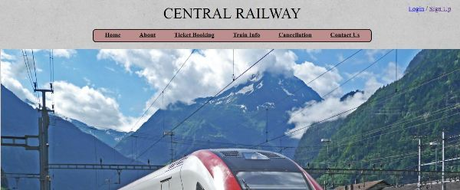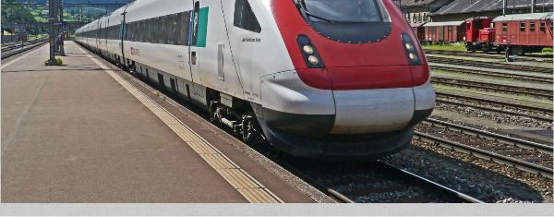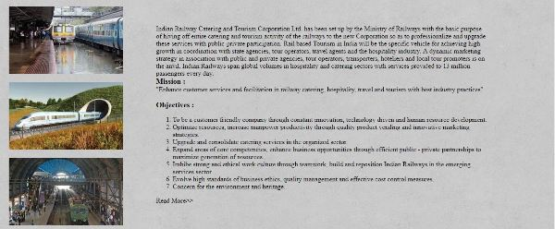

TRAIN STATUS

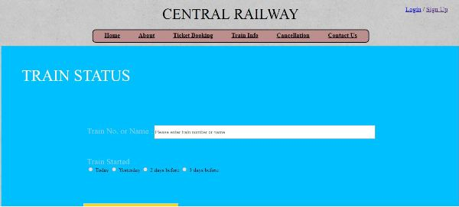

PNR STATUS

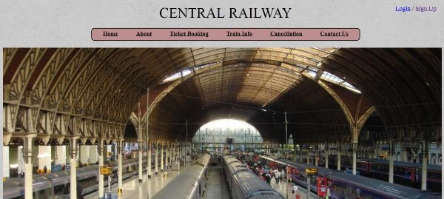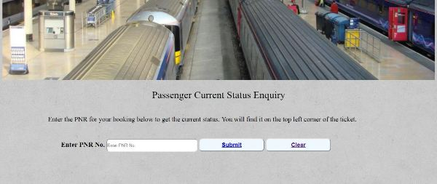

REGISTRATION

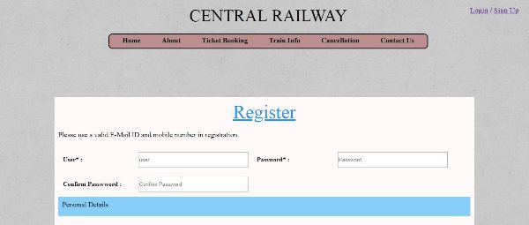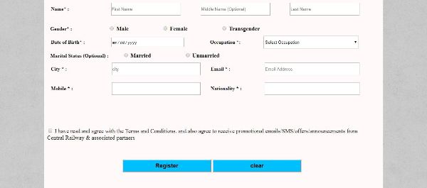C:\Users\SHUBHAM\AppData\Local\Microsoft\Windows\Temporary Internet Files\Content.Word\r3.jpg

LOGIN

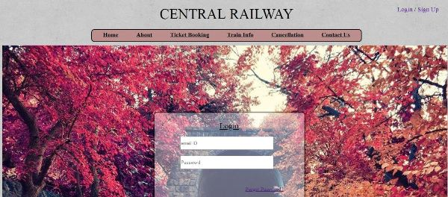

BOOK TICKET

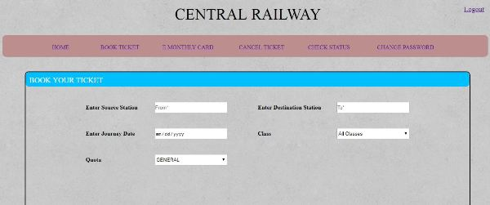C:\Users\SHUBHAM\AppData\Local\Microsoft\Windows\Temporary Internet Files\Content.Word\bo2.jpg

E CARD

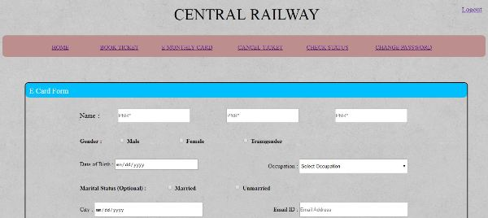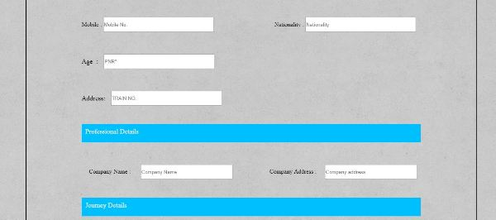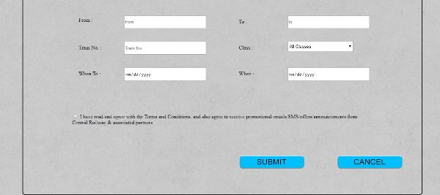

CANCEL TICKET

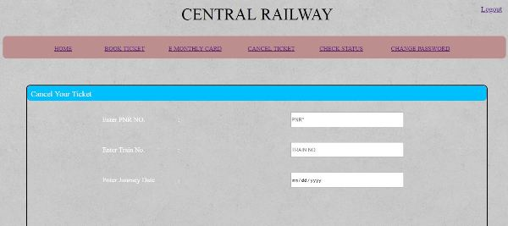C:\Users\SHUBHAM\AppData\Local\Microsoft\Windows\Temporary Internet Files\Content.Word\CT2.jpg

CHANGE PASSWORD

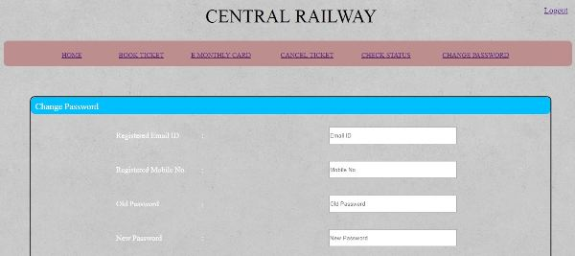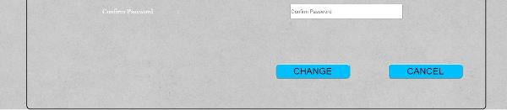

**Testing**

* **Functional Testing**

Functional testing is a type of [black box testing](http://en.wikipedia.org/wiki/Black_box_testing) that bases its test cases on the specifications of the project component under test. Functions are tested by feeding them input and examining the output, and internal program structure is rarely considered (Not like in [white-box testing](http://en.wikipedia.org/wiki/White-box_testing)).

Functional testing differs from [system testing](http://en.wikipedia.org/wiki/System_testing) in that functional testing a program by checking it against ... design document or specification", while system testing "validate a program by checking it against the published user or system requirements.

**Functional testing typically involves five steps:**

1. The identification of functions that the software is expected to perform
2. The creation of input data based on the function's specifications
3. The determination of output based on the function's specifications
4. The execution of the test case
5. The comparison of actual and expected outputs

**System testing** of software or hardware is testing conducted on a complete, integrated system to evaluate the system's compliance with its specified [requirements](http://en.wikipedia.org/wiki/Requirements). System testing falls within the scope of [black box testing](http://en.wikipedia.org/wiki/Black_box_testing), and as such, should require no knowledge of the inner design of the code or logic.

* **Structural Testing**

It determines the durability and integrity of complete structures or sub-assemblies, usually in multi-axis testing systems that replicate end use conditions.  The product range extends from single-axis component testing through to complex testing systems for the simulation of almost all service loads affecting a vehicle or component. IST offers a wide range of modular

standard testing systems for use in the automotive industry to test car components such as suspensions and steering systems.  Alternatively, systems can be engineered to meet specific customer requirements.

* **Unit Testing**

Unit testingis a method of testing that verifies the individual units of source code are working properly.

* **Integration Testing**

Integration testing is a process of combining multiple modules systematically for conducting tests in order to find errors in the interface between modules. The goal here is to see if the modules can be integrated properly. Hence, the emphasis is on testing the interfaces between modules.

* **System Testing**

In the system testing, the entire software system is tested. The reference document for this purpose is the requirements document, and the objective is to see if the software meets its requirements.

* **Testing of the Project**

**Test Case # 1 – USER LOGIN**

|  |  |  |
| --- | --- | --- |
| **TEST UNIT** | **TEST CASE** | **RESULT** |
| **Log In Button** | An invalid username(which is the email id in this case) or password is entered by the user | The website generates a message saying “invalid user id” or invalid password, whichever is the case. |
| **Log In Button** | A valid username and password is entered by the user | The website logs on the user and transfers him to the booking page. |

**Test Case # 2 – USER REGISTRATION**

|  |  |  |
| --- | --- | --- |
| **TEST UNIT** | **TEST CASE** | **RESULT** |
| **Register** | Passwords and Confirm Password fields do not match in the registration page | The website generates a message to the user saying “please enter the confirm password field” again. |
| **Register** | Data Fields left out empty in the registration page. | The system prompts a message to the user asking him to fill the empty fields he has left out. |
| **Register** | Correct data entered into the fields in the register page | The system accepts the details of the customer and then logs him onto the website and displays the page where he can search and book for tickets and cancel tickets. |

**Test Case # 3 – BOOK TICKETS**

|  |  |  |
| --- | --- | --- |
| **TEST UNIT** | **TEST CASE** | **RESULT** |
| **Book train tickets** | Correct format of data is entered into the data fields in the flight booking page. | The system allows the users to book the flight by providing details required and directs them |

**Test Case # 4 – CANCELS TICKETS**

|  |  |  |
| --- | --- | --- |
| **TEST UNIT** | **TEST CASE** | **RESULT** |
| **Cancellation** | An invalid data is entered by the user | The website generates a message saying “invalid data”. |
| **Cancellation** | A valid data is entered by the user | The website cancel the reserved tickets . |

**Test Case # 5 – PNR STATUS**

|  |  |  |
| --- | --- | --- |
| **TEST UNIT** | **TEST CASE** | **RESULT** |
| **PNR** | An invalid PNR id is entered by the user | The system generates a message saying “invalid PNR id”. |
| **PNR** | A valid PNR id is entered by the user | The website show PNR status to user . |

**Implementation**

* **Implementation of the project**

**REGISTRATION FORM**

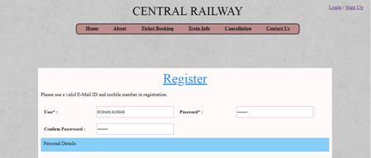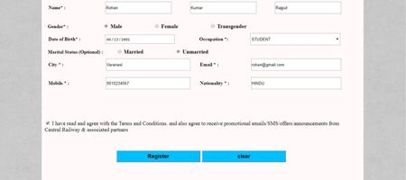C:\Users\SHUBHAM\AppData\Local\Microsoft\Windows\Temporary Internet Files\Content.Word\RE2.jpg

OUTPUT

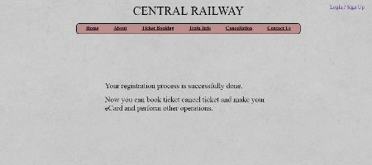

**LOGIN FORM**

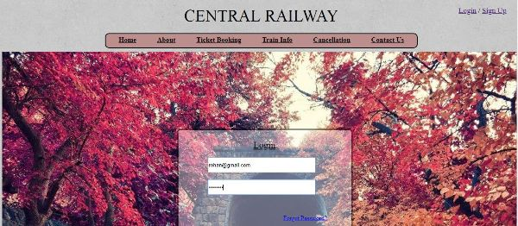 

OUTPUT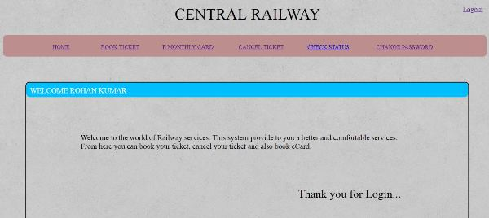 C:\Users\SHUBHAM\AppData\Local\Microsoft\Windows\Temporary Internet Files\Content.Word\LO_O1.jpg

**Source Code**

**HOME**

<html>

<head>

<title>Railway</title>

<link href="css/s.css" rel="stylesheet" > </link>

<link href="css/home.css" rel="stylesheet"> </link>

<link rel="stylesheet" href="css/general.css">

<link href="http://fonts.googleapis.com/css?family=Raleway:400,100,200,300,600,500,800,700,900" rel="stylesheet">

<link href="http://fonts.googleapis.com/css?family=Montserrat:400,700" rel="stylesheet">

<link href="http://fonts.googleapis.com/css?family=Open+Sans:300italic,400italic,600italic,

700italic,800italic,300,400,600,700,800&amp;subset=latin,cyrillic-ext,cyrillic,latin-ext" rel="stylesheet">

<link href="https://stackpath.bootstrapcdn.com/font-awesome/4.7.0/css/font-awesome.min.css" rel="stylesheet" >

</head>

<style type="text/css"></style>

<body background="images/backg.jpg">

<div class="wrap">

<center><font color=black>CENTRAL RAILWAY</center>

</div></font>

<div class="div\_1">

<a href="log.html">Login</a> /<a href="register.html"> Sign Up</a>

</div>

<div id="div\_2"><center>

<div id="links">

<font size=4><center><b>

<a href="R2.html"><font size=4 color=black>Home</font></a>

&nbsp&nbsp&nbsp&nbsp&nbsp&nbsp&nbsp&nbsp&nbsp&nbsp

<a href="about.html"><font size=4 color=black>About</font></a>

&nbsp&nbsp&nbsp&nbsp&nbsp&nbsp&nbsp&nbsp&nbsp&nbsp

<a href="reserv.html"><font size=4 color=black>Ticket Booking</font></a>

&nbsp&nbsp&nbsp&nbsp&nbsp&nbsp&nbsp&nbsp&nbsp&nbsp

<a href="trinfo.html"><font size=4 color=black>Train Info</font></a>

&nbsp&nbsp&nbsp&nbsp&nbsp&nbsp&nbsp&nbsp&nbsp&nbsp

<a href="cancel.html"><font size=4 color=black>Cancellation</font></a>

&nbsp&nbsp&nbsp&nbsp&nbsp&nbsp&nbsp&nbsp&nbsp&nbsp

<a href="conus.html"><font size=4 color=black>Contact Us</a></font></b> </center>

</div>

</div></center>

<div class="mid">

<img src="images\Home.jpg" width=1330px height=500px>

<div class="div\_3">

<center><font color=white>CENTRAL RAILWAY</center>

<div style='font-size:0.6em;width:630px;height:50px;padding:0px;float:right;'>

<center>SAFETY | SECURETY | PUNCTUALITY</center></font>

</div>

</div>

<div style='width:1330px;height:150px;padding:10px;float:left;font-size:2.4em;'>

<center><font style='position:relative;top:30px;' color=black>Haven't Find Suitable services?<br>

Then try our service and offers</center>

</font>

</div>

<div style='width:330px;height:450px;float:left;margin:55px;background-color:silver;'>

<img src="images/exterior.jpg" width=330px height=190px></img>

<div style='width:300px;height:240px;float:left; position:relative;top:10px;left:15px;'>

<h3>Maharaja's Express</h3><font size=3>

Redefining Royalty, Luxury and Comfort,

Maharajas’ express takes you on a sojourn to

the era of bygone stately splendour of princely

states. Sylvan furnishings, elegant ambience

and modern amenities are amalgamated for an

“Experience Unsurpassed”. It has been a winner

of “World’s Leading Luxury train” by World

Travel Awards consecutively for last six years.</div>

</div>

<div style='width:330px;height:450px;float:left;margin:55px;background-color:silver;'>

<img src="images/Kashmir.jpg" width=330px height=190px></img>

<div style='width:300px;height:240px;float:left; position:relative;top:10px;left:15px;'>

<h3>Domestic Tour</h3><font size=3>

Be it the spiritual devotee seeking blessings of

Tirupati, Shirdi or Mata Vaishno Devi or the

leisure traveller wanting to relish the Blue

mountains of North East, Sand-dunes of

Rajasthan, Hamlets of Ladakh, Wonders of

Himalayas, Serene lakes or Picturesque

Islands, Central Railway has it all. Discover India through

Central Railway!<br>

<a href="reserv.html"> Book ticket Now</a></div>

</div>

<div style='width:330px;height:450px;float:left;margin:55px;background-color:silver;'>

<img src="images/so3.png" width=330px height=190px></img>

<div style='width:300px;height:200px;float:left;position:relative;top:10px;left:15px;'>

<h3>TRAIN TICKET</h3><br>

100% cashback on train tickets!

One lucky winner everyday!<br>

Valid Upto 31 Oct

<p align=right> T&C </p>

<center>

<a href="so.html">For More Offers</a>

</center></div>

</div>

<div class="other">

<center>

<table width=900px cellpadding="1" cellspacing="10">

<caption ><h2><font color=teal>Quick Links</font></h2></caption>

<tr>

<td ><a href="reserv.html">Book Ticket</a></td>

<td><a href="so.html">Special Offers</a></td>

<td><a href="career.html">Careers</a></td>

</tr>

<tr>

<td ><a href="ftrain.html">Find Train</a></td>

<td><a href="cancelled.html">Cancelled Train</a></td>

<td><a href="faq.html">FAQs</a></td>

</tr>

<tr>

<td ><a href="route.html">Train Status</a></td>

<td><a href="log.html">Login</a></td>

<td><a href="about.html">About Us</a></td>

</tr>

<tr>

<td ><a href="pnr.html">PNR Enquiry</a></td>

<td><a href="register.html">Get Registered</a></td>

<td><a href="conus.html">Contact Us</a></td>

</tr>

<tr>

<td ><a href="trinfo.html">Train Information</a></td>

<td><a href="fgpass.html">Forget Password</a></td>

<td><a href="sm.html">Site Map</a></td>

</tr></table></center>

<table align=center cellpadding=1px cellspacing=5px>

<tr> <td><font size=4 color=teal>follow us on </td>

<td><a href=""><img src="images/google.png" width=30px height=30px title="google" /></a>

<td><a href=""><img src="images/gmail.png" width=30px height=30px title="gmail" /></a>

<td><a href=""><img src="images/facebook.png" width=30px height=30px title="facebook"/></a>

<td><a href=""><img src="images/-youtube.png" width=30px height=30px title="youtube" /></a>

</tr></table></div>

<div style='width:1310px;height:55px;float:left;position:relative;top:60px;'>

<center><p><font color=teal>

Copyright © PM Creation 2018 The CENTRAL RAILWAY Ltd. All rights reserved. </font></p> </center></div>

</body>

</html>

**ABOUT US**

**<html>**

**<html>**

**<head>**

**<title>Railway</title>**

**<link href="css/s.css" rel="stylesheet" > </link>**

**<link rel="stylesheet" href="css/general.css">**

**<link href="http://fonts.googleapis.com/css?family=Raleway:400,100,200,300,600,500,800,700,900" rel="stylesheet">**

**<link href="http://fonts.googleapis.com/css?family=Montserrat:400,700" rel="stylesheet">**

**<link href="http://fonts.googleapis.com/css?family=Open+Sans:300italic,400italic,600italic,**

**700italic,800italic,300,400,600,700,800&amp;subset=latin,cyrillic-ext,cyrillic,latin-ext" rel="stylesheet">**

**</head>**

**<body background="images/backg.jpg">**

**<div style='font-size:2.7em;width:1330px;height:50px;padding:10px;float:left;'>**

**<center><font color=black>CENTRAL RAILWAY</center>**

**</div></font>**

**<div style='font-size:1.2em;width:130px;height:10px;padding:10px;float:left;position:absolute;right:12px;'>**

**<a href="log.html">Login</a> /**

**<a href="register.html"> Sign Up</a>**

**</div>**

**<div style='padding:5px;margin:5px;width:1330;float:left;'><center>**

**<div style='background-color:rosybrown;border: 2px solid black;width:800px;height:25px; padding:5px;margin:0px; border-radius:10px;'>**

**<font size=4><center><b>**

**<a href="R2.html"><font size=4 color=black>Home</font></a>**

**&nbsp&nbsp&nbsp&nbsp&nbsp&nbsp&nbsp&nbsp&nbsp&nbsp**

**<a href="about.html"><font size=4 color=black>About</font></a>**

**&nbsp&nbsp&nbsp&nbsp&nbsp&nbsp&nbsp&nbsp&nbsp&nbsp**

**<a href="reserv.html"><font size=4 color=black>Ticket Booking</font></a>**

**&nbsp&nbsp&nbsp&nbsp&nbsp&nbsp&nbsp&nbsp&nbsp&nbsp**

**<a href="trinfo.html"><font size=4 color=black>Train Info</font></a>**

**&nbsp&nbsp&nbsp&nbsp&nbsp&nbsp&nbsp&nbsp&nbsp&nbsp**

**<a href="cancel.html"><font size=4 color=black>Cancellation</font></a>**

**&nbsp&nbsp&nbsp&nbsp&nbsp&nbsp&nbsp&nbsp&nbsp&nbsp**

**<a href="conus.html"><font size=4 color=black>Contact Us</a></font></b> </center>**

**</div></font>**

**</div></center>**

**<img src="images\Home1.jpg" width=1340px vspace=10>**

**<div style='width:250px;height:530px;float:left;margin:25px;'>**

**<img src="images/images (5).jpg" vspace=10px height=163px width=275px></img>**

**<img src="images/images (2).jpg" vspace=10px width=275px height=163px></img>**

**<img src="images/images (6).jpg" width=275px height=163px vspace=10px></img>**

**</div>**

**<div style='width:800px;height:390px;padding:10px;float:left;margin:70px;background-color:;'>**

**Indian Railway Catering and Tourism Corporation Ltd.**

**has been set up by the Ministry of Railways with the**

**basic purpose of hiving off entire catering and tourism**

**activity of the railways to the new Corporation so as**

**to professionalize and upgrade these services with**

**public-private participation. Rail based Tourism in**

**India will be the specific vehicle for achieving**

**high growth in coordination with state agencies,**

**tour operators, travel agents and the hospitality**

**industry. A dynamic marketing strategy in**

**association with public and private agencies,**

**tour operators, transporters, hoteliers and local**

**tour promoters is on the anvil. Indian Railways span**

**global volumes in hospitality and catering sectors**

**with services provided to 13 million passengers every day.<br>**

**<font size=4><b>Mission :</b></font><br>**

**"Enhance customer services and facilitation in railway**

**catering, hospitality, travel and tourism with best**

**industry practices"<br><br>**

**<font size=4><b>Objectives :</b></font><br>**

**<ol>**

**<li>**

**To be a customer friendly company through constant**

**innovation, technology driven and human resource development.</li>**

**<li>**

**Optimize resources, increase manpower productivity through**

**quality product vending and innovative marketing strategies. </li>**

**<li>Upgrade and consolidate catering services in the organized sector. </li>**

**<li> Expand areas of core competencies, enhance business opportunities**

**through efficient public - private partnerships to maximize generation of resources. </li>**

**<li>Imbibe strong and ethical work culture through teamwork,**

**build and reposition Indian Railways in the emerging services sector. </li>**

**<li>Evolve high standards of business ethics, quality management**

**and effective cost control measures. </li>**

**<li>Concern for the environment and heritage.</li>**

**</ol>**

**Read More>>**

**</div>**

**<div style='width:1330px;height:265px;padding:0px;float:left;position:relative;background-image:url("images/bk.jpg");'>**

**<center>**

**<table width=900px cellpadding="1" cellspacing="10">**

**<caption ><h2><font color=teal>Quick Links</font></h2></caption>**

**<tr>**

**<td ><a href="reserv.html">Book Ticket</a></td>**

**<td><a href="so.html">Special Offers</a></td>**

**<td><a href="career.html">Careers</a></td>**

**</tr>**

**<tr>**

**<td ><a href="ftrain.html">Find Train</a></td>**

**<td><a href="cancelled.html">Cancelled Train</a></td>**

**<td><a href="faq.html">FAQs</a></td>**

**</tr>**

**<tr>**

**<td ><a href="route.html">Train Status</a></td>**

**<td><a href="log.html">Login</a></td>**

**<td><a href="about.html">About Us</a></td>**

**</tr>**

**<tr>**

**<td ><a href="pnr.html">PNR Enquiry</a></td>**

**<td><a href="register.html">Get Registered</a></td>**

**<td><a href="conus.html">Contact Us</a></td>**

**</tr>**

**<tr>**

**<td ><a href="trinfo.html">Train Information</a></td>**

**<td><a href="fgpass.html">Forget Password</a></td>**

**<td><a href="sm.html">Site Map</a></td>**

**</tr>**

**</table>**

**</center>**

**<table align=center cellpadding=1px cellspacing=5px>**

**<tr>**

**<td><font size=4 color=teal>follow us on </td>**

**<td><a href=""><img src="images/google.png" width=30px height=30px title="google" /></a>**

**<td><a href=""><img src="images/gmail.png" width=30px height=30px title="gmail" /></a>**

**<td><a href=""><img src="images/facebook.png" width=30px height=30px title="facebook"/></a>**

**<td><a href=""><img src="images/-youtube.png" width=30px height=30px title="youtube" /></a>**

**</tr>**

**</table>**

**</div>**

**<div style='width:1310px;height:55px;float:left;position:relative;top:0px;'> <center>**

**<p><font color=teal>**

**Copyright © PM Creation 2018 The CENTRAL RAILWAY Ltd. All rights reserved.**

**</font></p>**

**</center>**

**</div>**

**</body>**

**</html>**

**TRAIN STATUS**

<html>

<head>

<title>Railway</title>

<link href="css/s.css" rel="stylesheet" > </link>

<link rel="stylesheet" href="css/general.css">

<link href="http://fonts.googleapis.com/css?family=Raleway:400,100,200,300,600,500,800,700,900" rel="stylesheet">

<link href="http://fonts.googleapis.com/css?family=Montserrat:400,700" rel="stylesheet">

<link href="http://fonts.googleapis.com/css?family=Open+Sans:300italic,400italic,600italic,

700italic,800italic,300,400,600,700,800&amp;subset=latin,cyrillic-ext,cyrillic,latin-ext" rel="stylesheet">

</head>

<style type="text/css">

body{

background-image:url("images/backg.jpg");

width:100%;

height:100%;

visibility: visible;

}

</style>

<body>

<div style='font-size:2.7em;width:1330px;height:50px;padding:10px;float:left;'>

<center><font color=black>CENTRAL RAILWAY</center>

</div></font>

<div style='font-size:1.2em;width:130px;height:10px;padding:10px;float:left;position:absolute;right:12px;'>

<a href="log.html">Login</a> /

<a href="register.html"> Sign Up</a>

</div>

<div style='padding:5px;margin:5px;width:1330;float:left;'><center>

<div style='background-color:rosybrown;border: 2px solid black;width:800px;height:25px; padding:5px;margin:0px; border-radius:10px;'>

<font size=4><center><b>

<a href="R2.html"><font size=4 color=black>Home</font></a>

&nbsp&nbsp&nbsp&nbsp&nbsp&nbsp&nbsp&nbsp&nbsp&nbsp

<a href="about.html"><font size=4 color=black>About</font></a>

&nbsp&nbsp&nbsp&nbsp&nbsp&nbsp&nbsp&nbsp&nbsp&nbsp

<a href="reserv.html"><font size=4 color=black>Ticket Booking</font></a>

&nbsp&nbsp&nbsp&nbsp&nbsp&nbsp&nbsp&nbsp&nbsp&nbsp

<a href="trinfo.html"><font size=4 color=black>Train Info</font></a>

&nbsp&nbsp&nbsp&nbsp&nbsp&nbsp&nbsp&nbsp&nbsp&nbsp

<a href="cancel.html"><font size=4 color=black>Cancellation</font></a>

&nbsp&nbsp&nbsp&nbsp&nbsp&nbsp&nbsp&nbsp&nbsp&nbsp

<a href="conus.html"><font size=4 color=black>Contact Us</a></font></b> </center>

</div></font>

</div></center>

<div style='width:1350px;height:600px;padding:0px;float:left;margin:0px; background-color:deepskyblue;'>

<div style='font-size:2.9em;width:1230px;height:40px;padding:0px;float:left;margin:60px;'>

<font color=white>TRAIN STATUS</font></div><br>

<div style='width:900px;height:340px;padding:10px;float:left;position:absolute;top:360px;left:250px; '>

<form><font size=5 color=lightskyblue>Train No. or Name :</font>

<input type="text" placeholder="Please enter train number or name" maxlength=30 name="train no." style='width:650px;height:40px;'></input>

<br><br><br><br>

<font size=5 color=lightskyblue>Train Started</font><br>

<input type="radio" name="started" value="today"> Today</input>

<input type="radio" name="started" value="yesterday"> Yesterday</input>

<input type="radio" name="started" value="days before"> 2 days before</input>

<input type="radio" name="started" value="daysbefore"> 3 days before</input></div>

<button type="button" style='width:280px;height:50px; background-color:gold;position:absolute;top:600;left:250;'>

<font size=4 color=black>Check status</font></button>

</div>

<div style='width:1350px;height:265px;padding:0px;float:left;position:relative;top:190px;background-image:url("images/bk.jpg");'>

<center>

<table width=900px cellpadding="1" cellspacing="10">

<caption ><h2><font color=teal>Quick Links</font></h2></caption>

<tr>

<td ><a href="reserv.html">Book Ticket</a></td>

<td><a href="so.html">Special Offers</a></td>

<td><a href="career.html">Careers</a></td>

</tr>

<tr>

<td ><a href="ftrain.html">Find Train</a></td>

<td><a href="cancelled.html">Cancelled Train</a></td>

<td><a href="faq.html">FAQs</a></td>

</tr>

<tr>

<td ><a href="route.html">Train Status</a></td>

<td><a href="log.html">Login</a></td>

<td><a href="about.html">About Us</a></td>

</tr>

<tr>

<td ><a href="pnr.html">PNR Enquiry</a></td>

<td><a href="register.html">Get Registered</a></td>

<td><a href="conus.html">Contact Us</a></td>

</tr>

<tr>

<td ><a href="trinfo.html">Train Information</a></td>

<td><a href="fgpass.html">Forget Password</a></td>

<td><a href="sm.html">Site Map</a></td>

</tr>

</table>

</center>

<table align=center cellpadding=1px cellspacing=5px>

<tr>

<td><font size=4 color=teal>follow us on </td>

<td><a href=""><img src="images/google.png" width=30px height=30px title="google" /></a>

<td><a href=""><img src="images/gmail.png" width=30px height=30px title="gmail" /></a>

<td><a href=""><img src="images/facebook.png" width=30px height=30px title="facebook"/></a>

<td><a href=""><img src="images/-youtube.png" width=30px height=30px title="youtube" /></a>

</tr>

</table>

</div>

<div style='width:1310px;height:55px;float:left;position:relative;top:190px;'> <center>

<p><font color=teal>

Copyright © PM Creation 2018 The CENTRAL RAILWAY Ltd. All rights reserved.</font></p></center></div>

</body>

</html>

**BOOK TICKET**

<html>

<head>

<title>**Railway**</title>

<link href=**"css/s.css"** rel=**"stylesheet"** ></link>

<link rel=**"stylesheet"** href=**"css/general.css"**>

<link href=**"http://fonts.googleapis.com/css?family=Raleway:400,100,200,300,600,500,800,700,900"** rel=**"stylesheet"**>

<link href=**"http://fonts.googleapis.com/css?family=Montserrat:400,700"** rel=**"stylesheet"**>

<link href=**"http://fonts.googleapis.com/css?family=Open+Sans:300italic,400italic,600italic,**

**700italic,800italic,300,400,600,700,800&amp;subset=latin,cyrillic-ext,cyrillic,latin-ext"** rel=**"stylesheet"**>

</head>

<style type=**"text/css"**>

**body{**

**background-image:url("images/backg.jpg");**

**width:100%;**

**height:100%;**

**visibility: visible;**

**}**

</style>

<body>

<div style=**'font-size:2.7em;width:1330px;height:50px;padding:10px;float:left;'**>

<center><font color=black>**CENTRAL RAILWAY**</center>

</div></font>

<div style=**'font-size:1.2em;width:50px;height:10px;padding:10px;float:left;position:absolute;right:12px;'**>

<a href=**"logout.html"**>**Logout**</a>

</div>

<div style=**'width:1315px;height:40px;padding:10px;float:left;position:absolute;top:100px;background-color:rosybrown;border-radius:10px;'**>

<div style=**'width:1300px;height:20px;padding:10px;float:left;position:absolute;top:10px;'**>

<div style=**'width:100px;height:10px;padding:10px;float:left;position:absolute;top:5px;left:90px;'**>

<center>

<a href=**"login.php"**>**HOME**</a></center>

</div>

<div style=**'width:110px;height:10px;padding:10px;float:left;position:absolute;top:5px;left:250px;'**>

<a href=**"book\_ticket.html"**>**BOOK TICKET**</a>

</div>

<div style=**'width:145px;height:10px;padding:10px;float:left;position:absolute;top:5px;left:420px;'**>

<a href=**"e\_card.html"**>**E MONTHLY CARD**</a>

</div>

<div style=**'width:130px;height:10px;padding:10px;float:left;position:absolute;top:5px;left:630px;'**>

<a href=**"cancel\_ticket.html"**>**CANCEL TICKET**</a>

</div>

<div style=**'width:120px;height:10px;padding:10px;float:left;position:absolute;top:5px;left:820px;'**>

<a href=**"check\_status.html"**>**CHECK STATUS**</a>

</div>

<div style=**'width:160px;height:10px;padding:10px;float:left;position:absolute;top:5px;left:1010px;'**>

<a href=**"change\_password.html"**>**CHANGE PASSWORD**</a>

</div>

</div>

</div>

<div style=**'width:1200px;height:450px;padding:10px;float:left;position:absolute;top:200px;left:70px;border:2px solid black;border-radius:10px;'**>

<div style=**'font-size:1.3em;;width:1200px;height:20px;padding:10px;float:left;position:absolute;top:0px;left:0px;background-color:deepskyblue;border-radius:10px;'**>

<font color=**"white"**>**BOOK YOUR TICKET**</font>

</div>

<div style=**'width:1200px;height:20px;padding:10px;float:left;position:absolute;top:50px;left:0px;border-radius:10px;'**>

<center>

<table cellpadding=20px>

<tr>

<td><label><b>**Enter Source Station**&nbsp<**/b>**</label></td>

<td><input type=**"text"** size=**"20"** maxlength=**"50"** placeholder=**"From\*"** style=**'width:200px; height:30px;'**></td>

<td></td>

<td><label><b>**Enter Destination Station**</b></label></td>

<td><input type=**"text"** size=**"20"** maxlength=**"50"** placeholder=**"To\*"** style=**'width:200px; height:30px;'**></td></tr>

<tr>

<td><label><b>**Enter Journey Date**</b></label></td>

<td><input type=**"date"** size=**"20"** name=**"dt"** style=**'width:200px; height:30px;'**></td>

<td></td>

<td><label><b>**Class**</b></label></td>

<td>

<select name=**"class"** style=**"width:200px; height:30px;"**>

<option>**All Classes**</option>

<option> **AC First Class (1A)**</option>

<option>**AC 2 Tier (2A)**</option>

<option>**First Class (FC)**</option>

<option>**AC 3 Economy (3E)**</option>

<option>**Sleeper Class**</option>

<option>**Executive Class**</option>

<option>**Second Seating**</option>

</select></td>

</tr>

<tr>

<td><label><b>**Quota**</b></label></td>

<td>

<select name=**"quota"** style=**"width:200px; height:30px;"**>

<option>**GENERAL**</option>

<option> **LOWER BRETH/SR. CITIZEN**</option>

<option>**LADIES**</option>

<option>**TATKAL**</option>

<option>**DIVYAANG**</option>

</select></td>

</table></center>

<center>

<br><br><br><br><br>

<a href=**""**>

<button type=**"button"** style=**'width:200px;height:40px; background-color:deepskyblue;'**>

<font size=5> **Search**</button></a></font>

<a href=**"book\_ticket.html"**>

<button type=**"button"** style=**'width:200px;height:40px; background-color:deepskyblue;'**>

<font size=5> **Reset**</button></a></font>

</center>

</div>

</div>

</body>

</html>

**CANCEL TICKET**

<html>

<head>

<title>**Railway**</title>

<link href=**"css/s.css"** rel=**"stylesheet"** ></link>

<link rel=**"stylesheet"** href=**"css/general.css"**>

<link href=**"http://fonts.googleapis.com/css?family=Raleway:400,100,200,300,600,500,800,700,900"** rel=**"stylesheet"**>

<link href=**"http://fonts.googleapis.com/css?family=Montserrat:400,700"** rel=**"stylesheet"**>

<link href=**"http://fonts.googleapis.com/css?family=Open+Sans:300italic,400italic,600italic,**

**700italic,800italic,300,400,600,700,800&amp;subset=latin,cyrillic-ext,cyrillic,latin-ext"** rel=**"stylesheet"**>

</head>

<style type=**"text/css"**>

**body{**

**background-image:url("images/backg.jpg");**

**width:100%;**

**height:100%;**

**visibility: visible;**

**}**

</style>

<body>

<div style=**'font-size:2.7em;width:1330px;height:50px;padding:10px;float:left;'**>

<center><font color=black>**CENTRAL RAILWAY**</center>

</div></font>

<div style=**'font-size:1.2em;width:50px;height:10px;padding:10px;float:left;position:absolute;right:12px;'**>

<a href=**"logout.html"**>**Logout**</a>

</div>

<div style=**'width:1315px;height:40px;padding:10px;float:left;position:absolute;top:100px;background-color:rosybrown;border-radius:10px;'**>

<div style=**'width:1300px;height:20px;padding:10px;float:left;position:absolute;top:10px;'**>

<div style=**'width:100px;height:10px;padding:10px;float:left;position:absolute;top:5px;left:90px;'**>

<center>

<a href=**"login.php"**>**HOME**</a></center>

</div>

<div style=**'width:110px;height:10px;padding:10px;float:left;position:absolute;top:5px;left:250px;'**>

<a href=**"book\_ticket.html"**>**BOOK TICKET**</a>

</div>

<div style=**'width:145px;height:10px;padding:10px;float:left;position:absolute;top:5px;left:420px;'**>

<a href=**"e\_card.html"**>**E MONTHLY CARD**</a>

</div>

<div style=**'width:130px;height:10px;padding:10px;float:left;position:absolute;top:5px;left:630px;'**>

<a href=**"cancel\_ticket.html"**>**CANCEL TICKET**</a>

</div>

<div style=**'width:120px;height:10px;padding:10px;float:left;position:absolute;top:5px;left:820px;'**>

<a href=**"check\_status.html"**>**CHECK STATUS**</a>

</div>

<div style=**'width:160px;height:10px;padding:10px;float:left;position:absolute;top:5px;left:1010px;'**>

<a href=**"change\_password.html"**>**CHANGE PASSWORD**</a>

</div>

</div>

</div>

<div style=**'width:1200px;height:450px;padding:10px;float:left;position:absolute;top:200px;left:70px;'**>

<div style=**'width:1200px;height:450px;padding:10px;float:left;position:absolute;top:30px;left:0px;background-color:;border:2px solid black;border-radius:10px;'**>

<div style=**'font-size:1.3em;;width:1200px;height:20px;padding:10px;float:left;position:absolute;top:0px;left:0px;background-color:deepskyblue;border-radius:10px;'**>

<font color=**"white"**>**Cancel Your Ticket**</font>

</div>

<div style=**'width:900px;height:20px;padding:10px;float:left;position:absolute;top:70px;left:140px;'**>

<div style=**'width:300px;height:20px;padding:10px;float:left;position:absolute;top:0px;left:50px;'**>

<font size=4 color=**"White"**>**Enter PNR NO.** </font>

<div style=**'width:10px;height:20px;padding:10px;float:left;position:absolute;top:0px;left:200px;'**>

<font size=4 color=**"White"**>**:**</font>

</div>

</div>

<div style=**'width:300px;height:20px;padding:10px;float:left;position:absolute;top:0px;left:550px;'**>

<input type=**"text"** size=**"20"** maxlength=**"20"** placeholder=**"PNR\*"** style=**'position:absolute;top:0px;width:300px;height:40px;'**>

</div>

</div>

<div style=**'width:900px;height:20px;padding:10px;float:left;position:absolute;top:150px;left:140px;'**>

<div style=**'width:300px;height:20px;padding:10px;float:left;position:absolute;top:0px;left:50px;'**>

<font size=4 color=**"White"**>**Enter Train No.** </font>

<div style=**'width:10px;height:20px;padding:10px;float:left;position:absolute;top:0px;left:200px;'**>

<font size=4 color=**"White"**>**:**</font>

</div>

</div>

<div style=**'width:300px;height:20px;padding:10px;float:left;position:absolute;top:0px;left:550px;'**>

<input type=**"text"** size=**"20"** maxlength=**"20"** placeholder=**"TRAIN NO."** style=**'position:absolute;top:0px;width:300px;height:40px;'**>

</div>

</div>

<div style=**'width:900px;height:20px;padding:10px;float:left;position:absolute;top:230px;left:140px;'**>

<div style=**'width:300px;height:20px;padding:10px;float:left;position:absolute;top:0px;left:50px;'**>

<font size=4 color=**"White"**>**Enter Journey Date** </font>

<div style=**'width:10px;height:20px;padding:10px;float:left;position:absolute;top:0px;left:200px;'**>

<font size=4 color=**"White"**>**:**</font>

</div>

</div>

<div style=**'width:300px;height:20px;padding:10px;float:left;position:absolute;top:0px;left:550px;'**>

<input type=**"date"** size=**"20"** maxlength=**"20"** placeholder=**"DATE"** style=**'position:absolute;top:0px;width:300px;height:40px;'**>

</div>

</div>

<div style=**'width:500px;height:20px;padding:10px;float:left;position:absolute;top:380px;left:650px;'**>

<div style=**'width:200px;height:20px;padding:10px;float:left;position:absolute;top:0px;left:0px;'**>

<button type=**"submit"** style=**'width:200px;height:40px;position:absolute;top:0px; background-color:deepskyblue;border-radius:10px; '**>

<font size=5>**SUBMIT**</font></button>

</div>

<div style=**'width:200px;height:20px;padding:10px;float:left;position:absolute;top:0px;left:300px;'**>

<button type=**"submit"** style=**'width:200px;height:40px;position:absolute;top:0px; background-color:deepskyblue;border-radius:10px; '**>

<font size=5>**CANCEL**</font></button>

</div>

</div>

</div>

</div>

</body>

</html>

**PNR STATUS**

<html>

<head>

<title>**Railway**</title>

<link href=**"css/s.css"** rel=**"stylesheet"** ></link>

<link rel=**"stylesheet"** href=**"css/general.css"**>

<link href=**"http://fonts.googleapis.com/css?family=Raleway:400,100,200,300,600,500,800,700,900"** rel=**"stylesheet"**>

<link href=**"http://fonts.googleapis.com/css?family=Montserrat:400,700"** rel=**"stylesheet"**>

<link href=**"http://fonts.googleapis.com/css?family=Open+Sans:300italic,400italic,600italic,**

**700italic,800italic,300,400,600,700,800&amp;subset=latin,cyrillic-ext,cyrillic,latin-ext"** rel=**"stylesheet"**>

</head>

<style type=**"text/css"**>

**body{**

**background-image:url("images/backg.jpg");**

**width:100%;**

**height:100%;**

**visibility: visible;**

**}**

</style>

<body>

<div style=**'font-size:2.7em;width:1330px;height:50px;padding:10px;float:left;'**>

<center><font color=black>**CENTRAL RAILWAY**</center>

</div></font>

<div style=**'font-size:1.2em;width:130px;height:10px;padding:10px;float:left;position:absolute;right:12px;'**>

<a href=**"log.html"**>**Login**</a> **/**

<a href=**"register.html"**> **Sign Up**</a>

</div>

<div style=**'padding:5px;margin:5px;width:1330;float:left;'**><center>

<div style=**'background-color:rosybrown;border: 2px solid black;width:800px;height:25px; padding:5px;margin:0px; border-radius:10px;'**>

<font size=4><center><b>

<a href=**"R2.html"**><font size=4 color=black>**Home**</font></a>

&nbsp&**nbsp**&nbsp&**nbsp**&nbsp&**nbsp**&nbsp&**nbsp**&nbsp&**nbsp**

<a href=**"about.html"**><font size=4 color=black>**About**</font></a>

&nbsp&**nbsp**&nbsp&**nbsp**&nbsp&**nbsp**&nbsp&**nbsp**&nbsp&**nbsp**

<a href=**"reserv.html"**><font size=4 color=black>**Ticket Booking**</font></a>

&nbsp&**nbsp**&nbsp&**nbsp**&nbsp&**nbsp**&nbsp&**nbsp**&nbsp&**nbsp**

<a href=**"trinfo.html"**><font size=4 color=black>**Train Info**</font></a>

&nbsp&**nbsp**&nbsp&**nbsp**&nbsp&**nbsp**&nbsp&**nbsp**&nbsp&**nbsp**

<a href=**"cancel.html"**><font size=4 color=black>**Cancellation**</font></a>

&nbsp&**nbsp**&nbsp&**nbsp**&nbsp&**nbsp**&nbsp&**nbsp**&nbsp&**nbsp**

<a href=**"conus.html"**><font size=4 color=black>**Contact Us**</a></font></b></center>

</div></font>

</div></center>

<div style=**'width:1330;height:800px;position:relative;top:140px'**>

<div style=**'width:1330px;height:600px;position:absolute;'**>

<img src=**"images/pnr.jpg"** width=1330px height=700></img>

</div>

<div style=**'font-size:1.9em;width:1330;height:100px;position:relative;top:600px;'**>

<center>**Passenger Current Status Enquiry**</center>

</div>

<div style=**'font-size:1.3em;width:1000px;height:50px;position:relative;top:680px;left:140px;'**>

**Enter the PNR for your booking below to get the current status. You will find it on the top**

**left corner of the ticket.**

</div>

<div style=**'font-size:1.3em;width:1000px;height:50px;position:relative;top:730px;left:180px;'**>

<label><b>**Enter PNR No.** </b></label>

<input type=**"text"** style=**'width:280px;height:40px;border-radius:10px;'** name=**"pnrno"** placeholder=**"Enter PNR No."**>

</input>

<button type=**"button"** style=**'width:200px;height:40px;border-radius:10px; background-color:aliceblue;'**>

<font size=4><b><a href=**"page.html"**>**Submit**</a></b></font>

</button>

<button type=**"button"** style=**'width:200px;height:40px;border-radius:10px; background-color:aliceblue;'**>

<font size=4><b><a href=**"pnr.html"**>**Clear**</a></b></font>

</button>

</div>

</div>

<div style=**'width:1330px;height:265px;padding:0px;float:left;position:relative;top:440px;background-image:url("images/bk.jpg");'**>

<center>

<table width=900px cellpadding=**"1"** cellspacing=**"10"**>

<caption ><h2><font color=teal>**Quick Links**</font></h2></caption>

<tr>

<td ><a href=**"reserv.html"**>**Book Ticket**</a></td>

<td><a href=**"so.html"**>**Special Offers**</a></td>

<td><a href=**"career.html"**>**Careers**</a></td>

</tr>

<tr>

<td ><a href=**"ftrain.html"**>**Find Train**</a></td>

<td><a href=**"cancelled.html"**>**Cancelled Train**</a></td>

<td><a href=**"faq.html"**>**FAQs**</a></td>

</tr>

<tr>

<td ><a href=**"route.html"**>**Train Status**</a></td>

<td><a href=**"log.html"**>**Login**</a></td>

<td><a href=**"about.html"**>**About Us**</a></td>

</tr>

<tr>

<td ><a href=**"pnr.html"**>**PNR Enquiry**</a></td>

<td><a href=**"register.html"**>**Get Registered**</a></td>

<td><a href=**"conus.html"**>**Contact Us**</a></td>

</tr>

<tr>

<td ><a href=**"trinfo.html"**>**Train Information**</a></td>

<td><a href=**"fgpass.html"**>**Forget Password**</a></td>

<td><a href=**"sm.html"**>**Site Map**</a></td>

</tr>

</table>

</center>

<table align=center cellpadding=1px cellspacing=5px>

<tr>

<td><font size=4 color=teal>**follow us on** </td>

<td><a href=**""**><img src=**"images/google.png"** width=30px height=30px title=**"google"** /></a>

<td><a href=**""**><img src=**"images/gmail.png"** width=30px height=30px title=**"gmail"** /></a>

<td><a href=**""**><img src=**"images/facebook.png"** width=30px height=30px title=**"facebook"**/></a>

<td><a href=**""**><img src=**"images/-youtube.png"** width=30px height=30px title=**"youtube"** /></a>

</tr>

</table>

</div>

<div style=**'width:1310px;height:55px;float:left;position:relative;top:440;'**><center>

<p><font color=teal>

**Copyright © PM Creation 2018 The CENTRAL RAILWAY Ltd. All rights reserved.**</font></p></center></div>

</body>

</html>

**REGISTRATION**

<html>

<head>

<title>**Railway**</title>

<link href=**"css/s.css"** rel=**"stylesheet"** ></link>

<link rel=**"stylesheet"** href=**"css/general.css"**>

<link href=**"http://fonts.googleapis.com/css?family=Raleway:400,100,200,300,600,500,800,700,900"** rel=**"stylesheet"**>

<link href=**"http://fonts.googleapis.com/css?family=Montserrat:400,700"** rel=**"stylesheet"**>

<link href=**"http://fonts.googleapis.com/css?family=Open+Sans:300italic,400italic,600italic,**

**700italic,800italic,300,400,600,700,800&amp;subset=latin,cyrillic-ext,cyrillic,latin-ext"** rel=**"stylesheet"**>

</head>

<style type=**"text/css"**>

**body{**

**background-image:url("images/backg.jpg");**

**width:100%;**

**height:100%;**

**visibility: visible;**

**}**

</style>

<body>

<div style=**'font-size:2.7em;width:1330px;height:50px;padding:10px;float:left;'**>

<center><font color=black>**CENTRAL RAILWAY**</center>

</div></font>

<div style=**'font-size:1.2em;width:130px;height:10px;padding:10px;float:left;position:absolute;right:12px;'**>

<a href=**"log.html"**>**Login**</a> **/**

<a href=**"register.html"**> **Sign Up**</a>

</div>

<div style=**'padding:5px;margin:5px;width:1330;float:left;'**><center>

<div style=**'background-color:rosybrown;border: 2px solid black;width:800px;height:25px; padding:5px;margin:0px; border-radius:10px;'**>

<font size=4><center><b>

<a href=**"R2.html"**><font size=4 color=black>**Home**</font></a>

&nbsp&**nbsp**&nbsp&**nbsp**&nbsp&**nbsp**&nbsp&**nbsp**&nbsp&**nbsp**

<a href=**"about.html"**><font size=4 color=black>**About**</font></a>

&nbsp&**nbsp**&nbsp&**nbsp**&nbsp&**nbsp**&nbsp&**nbsp**&nbsp&**nbsp**

<a href=**"reserv.html"**><font size=4 color=black>**Ticket Booking**</font></a>

&nbsp&**nbsp**&nbsp&**nbsp**&nbsp&**nbsp**&nbsp&**nbsp**&nbsp&**nbsp**

<a href=**"trinfo.html"**><font size=4 color=black>**Train Info**</font></a>

&nbsp&**nbsp**&nbsp&**nbsp**&nbsp&**nbsp**&nbsp&**nbsp**&nbsp&**nbsp**

<a href=**"cancel.html"**><font size=4 color=black>**Cancellation**</font></a>

&nbsp&**nbsp**&nbsp&**nbsp**&nbsp&**nbsp**&nbsp&**nbsp**&nbsp&**nbsp**

<a href=**"conus.html"**><font size=4 color=black>**Contact Us**</a></font></b></center>

</div>

</div></center>

<div style=**'width:1360px;height:1000px;padding:0px;float:left;margin:0px;position:absolute;top:200px;'**>

<div style=**'background-color:snow;width:1050px;height:1000px;padding:10px;float:left;margin:50px;position:relative;left:80px;'**>

<center><font size=7 color=dodgerblue><u>**Register**</u></font></center><br>

**Please use a valid E-Mail ID and mobile number in registration.**<br>

<br>

<form action=**"register.php"** method=**"post"**>

<table cellpadding=10px >

<tr>

<td><b>**User\* :**</b></td>

<td style=**'position:relative;left:20px'**>

<input type=**"text"** placeholder=**"user"** maxlength=30 name=**"username"** style=**'width:280px;height:40px;'** required></input>

</td>

<td style=**'position:relative;left:20px;'**><b>**Password\* :**</b></td>

<td style=**'position:relative;left:120px'**>

<input type=**"password"** placeholder=**"Password"** maxlength=30 name=**"password"** style=**'width:280px;height:40px;'** required></input>

</td></tr>

<tr>

<td style=**'padding:10px;'**><b>**Confirm Passwword :**</b></td>

<td style=**'position:relative;left:20px;'**>

<input type=**"password"** placeholder=**"Confirm Password"** maxlength=20 name=**"confirmPassword"** style=**'width:280px;height:40px;'** required></input>

</td></tr>

</table>

<div style=**'background-color:lightskyblue;width:1030px;height:30px;padding:10px;float:left;'**>

**Personal Details**</div>

<table cellpadding=30px>

<tr>

<td style=**'padding:10px;'**><b>**Name\* :** </b></td>

<td style=**'position:relative;left:90px;'**>

<input type=**"text"** placeholder=**"First Name"** maxlength=50 name=**"firstName"** style=**'width:220px;height:40px;'**></input>

</td>

<td style=**'position:relative;left:90px;'**>

<input type=**"text"** placeholder=**"Middle Name (Optional)"** maxlength=30 name=**"midName"** style=**'width:220px;height:40px;'**></input>

</td>

<td style=**'position:relative;left:90px;'**>

<input type=**"text"** placeholder=**"Last Name"** maxlength=20 name=**"lastName"** style=**'width:220px;height:40px;'**></input>

</td></tr>

</table>

<font size=3 style=**'position:relative;left:10px'** ><b>**Gender\* :** </b></font>

<input type=**"radio"** name=**"gender"** value=**"Male"**style=**'position:relative;left:120px;'** required>

<font style=**'position:relative;left:120px;'**><b>**Male**</b></font></input>

<input type=**"radio"** name=**"gender"** value=**"Female"** style=**'position:relative;left:220px;'** required>

<font style=**'position:relative;left:220px;'**><b>**Female**</b></font></input>

<input type=**"radio"** name=**"gender"** value=**"Transgender"** style=**'position:relative;left:320px;'** required>

<font style=**'position:relative;left:320px;'**><b>**Transgender**</b></font></input><br>

<table cellpadding=10px >

<tr>

<td><b>**Date of Birth\* :**</b></td>

<td style=**'position:relative;left:60px'**>

<input type=**"date"** placeholder=**""** maxlength=30 name=**"DOB"** style=**'width:230px;height:30px;'** required></input>

</td>

<td style=**'position:relative;left:120px;'**><b>**Occupation \*:**</b></td>

<td style=**'position:relative;left:170px'**>

<select name=**"Occupation"** style=**"width:300px; height:40px;"**>

<option disabled selected hidden>**Select Occupation**</option>

<option>**GOVERNMENT** </option>

<option>**PUBLIC**</option>

<option>**PRIVATE**</option>

<option>**PROFESSIONAL**</option>

<option>**SELF EMPLOYED**</option>

<option>**STUDENT** </option>

<option>**OTHER**</option>

</select>

</td></tr>

</table>

<font size=3 style=**'position:relative;left:10px'** ><b>**Marital Status (Optional) :** </b></font>

<input type=**"radio"** name=**"MaritalStatus"** value=**"Married"**style=**'position:relative;left:50px;'** required>

<font style=**'position:relative;left:50px;'**><b>**Married**</b></font></input>

<input type=**"radio"** name=**"MaritalStatus"** value=**"Unmarried"** style=**'position:relative;left:150px;'** required>

<font style=**'position:relative;left:150px;'**><b>**Unmarried**</b></font></input>

<table cellpadding=10px >

<tr>

<td><b>**City \* :**</b></td>

<td style=**'position:relative;left:100px'**>

<input type=**"text"** placeholder=**"city"** maxlength=30 name=**"city"** style=**'width:280px;height:40px;'** required></input>

</td>

<td style=**'position:relative;left:110px;'**><b>**Email \* :**</b></td>

<td style=**'position:relative;left:160px'**>

<input type=**"email"** placeholder=**"Email Address"** maxlength=30 name=**"email"** style=**'width:300px;height:40px;'** required></input>

</td></tr>

<tr>

<td><b>**Mobile \* :**</b></td>

<td style=**'position:relative;left:100px'**>

<input type=**"text"** placeholder=**""** maxlength=10 name=**"mobile"** style=**'width:280px;height:40px;'** required></input>

</td>

<td style=**'position:relative;left:110px;'**><b>**Nationality \* :**</b></td>

<td style=**'position:relative;left:160px'**>

<input type=**"text"** maxlength=30 name=**"nationality"** style=**'width:300px;height:40px;'** required></input>

</td></tr>

</table>

<br><br>

<div style=**'position:relative;top:50px;width:1008px;height:50px;'**>

<input type=**"checkbox"** name=**"term"** value=**"condition"** required></input>

**I have read and agree with the Terms and Conditions. and also agree to receive promotional emails/SMS/offers/announcements from Central**

**Railway** & **associated partners**</div>

<div style=**'position:relative;left:120px;top:100px; width:800px;height:50px;'**>

<center>

<button type=**"submit"** style=**'width:280px;height:40px; background-color:deepskyblue;'**>

<font size=4 color=black><b>**Register**</b></font>

</button>

<a href=**"register.html"**>

<button type=**"button"** style=**'width:280px;height:40px; background-color:deepskyblue;'**>

<b><font size=4 color=black>**clear**</b></font>

</button></a></center></div>

</form></div></div>

</body>

</html>

**AFTER REGISTRATION**

<html>

<head>

<title>**Railway**</title>

<link href=**"css/s.css"** rel=**"stylesheet"** ></link>

<link rel=**"stylesheet"** href=**"css/general.css"**>

<link href=**"http://fonts.googleapis.com/css?family=Raleway:400,100,200,300,600,500,800,700,900"** rel=**"stylesheet"**>

<link href=**"http://fonts.googleapis.com/css?family=Montserrat:400,700"** rel=**"stylesheet"**>

<link href=**"http://fonts.googleapis.com/css?family=Open+Sans:300italic,400italic,600italic,**

**700italic,800italic,300,400,600,700,800&amp;subset=latin,cyrillic-ext,cyrillic,latin-ext"** rel=**"stylesheet"**>

</head>

<style type=**"text/css"**>

**body{**

**background-image:url("images/backg.jpg");**

**width:100%;**

**height:100%;**

**visibility: visible;**

**}**

</style>

<body>

<div style=**'font-size:2.7em;width:1330px;height:50px;padding:10px;float:left;'**>

<center><font color=black>**CENTRAL RAILWAY**</center>

</div></font>

<div style=**'font-size:1.2em;width:130px;height:10px;padding:10px;float:left;position:absolute;right:12px;'**>

<a href=**"log.html"**>**Login**</a> **/**

<a href=**"register.html"**> **Sign Up**</a>

</div>

<div style=**'padding:5px;margin:5px;width:1330;float:left;'**><center>

<div style=**'background-color:rosybrown;border: 2px solid black;width:800px;height:25px; padding:5px;margin:0px; border-radius:10px;'**>

<font size=4><center><b>

<a href=**"R2.html"**><font size=4 color=black>**Home**</font></a>

&nbsp&**nbsp**&nbsp&**nbsp**&nbsp&**nbsp**&nbsp&**nbsp**&nbsp&**nbsp**

<a href=**"about.html"**><font size=4 color=black>**About**</font></a>

&nbsp&**nbsp**&nbsp&**nbsp**&nbsp&**nbsp**&nbsp&**nbsp**&nbsp&**nbsp**

<a href=**"reserv.html"**><font size=4 color=black>**Ticket Booking**</font></a>

&nbsp&**nbsp**&nbsp&**nbsp**&nbsp&**nbsp**&nbsp&**nbsp**&nbsp&**nbsp**

<a href=**"trinfo.html"**><font size=4 color=black>**Train Info**</font></a>

&nbsp&**nbsp**&nbsp&**nbsp**&nbsp&**nbsp**&nbsp&**nbsp**&nbsp&**nbsp**

<a href=**"cancel.html"**><font size=4 color=black>**Cancellation**</font></a>

&nbsp&**nbsp**&nbsp&**nbsp**&nbsp&**nbsp**&nbsp&**nbsp**&nbsp&**nbsp**

<a href=**"conus.html"**><font size=4 color=black>**Contact Us**</a></font></b></center></div></div></center>

<div style=**'width:600px;height:200px;position:absolute;top:200px;left:230px;;'**>

<div style=**'font-size:1.5em;width:600px;height:50px;position:absolute;top:100px;left:150px;'**>

<?php

$username = $\_POST['username'];

$password = $\_POST['password'];

$confirmPassword = $\_POST['confirmPassword'];

$firstName = $\_POST['firstName'];

$midName = $\_POST['midName'];

$lastName = $\_POST['lastName'];

$gender = $\_POST['gender'];

$DOB = $\_POST['DOB'];

$occupation = $\_POST['Occupation'];

$MaritalStatus = $\_POST['MaritalStatus'];

$city = $\_POST['city'];

$email = $\_POST['email'];

$mobile = $\_POST['mobile'];

$nationality = $\_POST['nationality'];

**if** (!**empty**($username) || !**empty**($password) || !**empty**($gender) || !**empty**($email) || !**empty**($confirmPassword) || !**empty**($mobile)) {

$host = "localhost";

$dbUsername = "root";

$dbPassword = "";

$dbname = "youtube";

//create connection

$conn = **new** mysqli($host, $dbUsername, $dbPassword, $dbname);

**if** (**mysqli\_connect\_error**()) {

**die**('Connect Error('. **mysqli\_connect\_errno**().')'. **mysqli\_connect\_error**());

} **else** {

$SELECT = "SELECT email From register Where email = ? Limit 1";

$INSERT = "INSERT Into register (username, password, confirmPassword, firstName, midName, lastName,

gender, DOB, occupation, MaritalStatus, city, email, mobile, nationality) values(?, ?, ?, ?, ?, ?, ?, ?, ?, ?, ?, ?, ?, ?)";

//Prepare statement

$stmt = $conn->prepare($SELECT);

$stmt->bind\_param("s", $email);

$stmt->execute();

$stmt->bind\_result($email);

$stmt->store\_result();

$rnum = $stmt->num\_rows;

**if** ($rnum==0) {

$stmt->close();

$stmt = $conn->prepare($INSERT);

$stmt->bind\_param("ssssssssssssis", $username, $password, $confirmPassword, $firstName, $midName, $lastName, $gender, $DOB, $occupation, $MaritalStatus, $city, $email, $mobile, $nationality);

$stmt->execute();

**echo** "Your registration process is successfully done.";

**echo** "<div style='width:600px;height:50px;position:absolute;top:50px;left:0px;'>

Now you can book ticket cancel ticket and make your eCard and perform other operations. </div>";

} **else** {

**echo** "Someone already register using this email use another";

}

$stmt->close();

$conn->close();

}

} **else** {

**echo** "All field are required";

**die**();

}

?>

</div>

</body>

</html>

**LOGIN**

<html>

<head>

<title>**Railway**</title>

<link href=**"css/s.css"** rel=**"stylesheet"** ></link>

<link rel=**"stylesheet"** href=**"css/general.css"**>

<link href=**"http://fonts.googleapis.com/css?family=Raleway:400,100,200,300,600,500,800,700,900"** rel=**"stylesheet"**>

<link href=**"http://fonts.googleapis.com/css?family=Montserrat:400,700"** rel=**"stylesheet"**>

<link href=**"http://fonts.googleapis.com/css?family=Open+Sans:300italic,400italic,600italic,**

**700italic,800italic,300,400,600,700,800&amp;subset=latin,cyrillic-ext,cyrillic,latin-ext"** rel=**"stylesheet"**>

</head>

<style type=**"text/css"**>

**body{**

**background-image:url("images/backg.jpg");**

**width:100%;**

**height:100%;**

**visibility: visible;**

**}**

</style>

<body>

<div style=**'font-size:2.7em;width:1330px;height:50px;padding:10px;float:left;'**>

<center><font color=black>**CENTRAL RAILWAY**</center>

</div></font>

<div style=**'font-size:1.2em;width:130px;height:10px;padding:10px;float:left;position:absolute;right:12px;'**>

<a href=**"log.html"**>**Login**</a> **/**

<a href=**"register.html"**> **Sign Up**</a>

</div>

<div style=**'padding:5px;margin:5px;width:1330;float:left;'**><center>

<div style=**'background-color:rosybrown;border: 2px solid black;width:800px;height:25px; padding:5px;margin:0px; border-radius:10px;'**>

<font size=4><center><b>

<a href=**"R2.html"**><font size=4 color=black>**Home**</font></a>

&nbsp&**nbsp**&nbsp&**nbsp**&nbsp&**nbsp**&nbsp&**nbsp**&nbsp&**nbsp**

<a href=**"about.html"**><font size=4 color=black>**About**</font></a>

&nbsp&**nbsp**&nbsp&**nbsp**&nbsp&**nbsp**&nbsp&**nbsp**&nbsp&**nbsp**

<a href=**"reserv.html"**><font size=4 color=black>**Ticket Booking**</font></a>

&nbsp&**nbsp**&nbsp&**nbsp**&nbsp&**nbsp**&nbsp&**nbsp**&nbsp&**nbsp**

<a href=**"trinfo.html"**><font size=4 color=black>**Train Info**</font></a>

&nbsp&**nbsp**&nbsp&**nbsp**&nbsp&**nbsp**&nbsp&**nbsp**&nbsp&**nbsp**

<a href=**"cancel.html"**><font size=4 color=black>**Cancellation**</font></a>

&nbsp&**nbsp**&nbsp&**nbsp**&nbsp&**nbsp**&nbsp&**nbsp**&nbsp&**nbsp**

<a href=**"conus.html"**><font size=4 color=black>**Contact Us**</a></font></b></center>

</div></font>

</div></center>

<div style=**'width:1340px;height:800px;padding:0px;float:left;background-image:url("images/logbk.jpg");'**>

<div style=**'width:450px;height:450px;float:left;position:relative;top:200px;left:455px;opacity:0.4; border-radius:10px;background-color:white; border:4px solid black;'**>

</div>

<form method=**"post"** action=**"login.php"**>

<div style=**'width:350px;height:360px;float:left;position:relative;top:230px;left:50px; '**>

<center><font size=5><u>**Login**</u></font><br></center><br>&nbsp&**nbsp**&nbsp&**nbsp**&nbsp&**nbsp**

<input type=**"text"** placeholder=**"email ID"** maxlength=90 name=**"email"** style=**'width:280px;height:40px;'** required></input><br><br>

&nbsp&**nbsp**&nbsp&**nbsp**&nbsp&**nbsp**

<input type=**"password"** placeholder=**"Password"** maxlength=30 name=**"password"** style=**'width:280px;height:40px;'** required></input><br><br>

&nbsp&**nbsp**&nbsp&**nbsp**&nbsp&**nbsp**

<p align=right><a href=**"fgpass.html"**>**Forget Password?**</a>&nbsp&**nbsp**&nbsp<**/p>**

&nbsp&**nbsp**&nbsp&**nbsp**&nbsp&**nbsp**

<button type=**"submit"** style=**'width:280px;height:40px; background-color:dodgerblue;'**>

<a href=**""**><font size=4 color=white><b>**Sign in**</b></font></a></button><br><br>

&nbsp&**nbsp**&nbsp&**nbsp**&nbsp&**nbsp**

<button type=**"button"** style=**'width:280px;height:40px; background-color:aliceblue;'**>

<font size=4><b><a href=**"register.html"**>**Register**</a></b></font>

</button></div></form><center>

</center>

</div>

</body>

</html>

**AFTER LOGIN**

<html>

<head>

<title>**Railway**</title>

<link href=**"css/s.css"** rel=**"stylesheet"** ></link>

<link rel=**"stylesheet"** href=**"css/general.css"**>

<link href=**"http://fonts.googleapis.com/css?family=Raleway:400,100,200,300,600,500,800,700,900"** rel=**"stylesheet"**>

<link href=**"http://fonts.googleapis.com/css?family=Montserrat:400,700"** rel=**"stylesheet"**>

<link href=**"http://fonts.googleapis.com/css?family=Open+Sans:300italic,400italic,600italic,**

**700italic,800italic,300,400,600,700,800&amp;subset=latin,cyrillic-ext,cyrillic,latin-ext"** rel=**"stylesheet"**>

</head>

<style type=**"text/css"**>

**body{**

**background-image:url("images/backg.jpg");**

**width:100%;**

**height:100%;**

**visibility: visible;**

**}**

</style>

<body>

<div style=**'font-size:2.7em;width:1330px;height:50px;padding:10px;float:left;'**>

<center><font color=black>**CENTRAL RAILWAY**</center>

</div></font>

<div style=**'font-size:1.2em;width:50px;height:10px;padding:10px;float:left;position:absolute;right:12px;'**>

<a href=**"logout.html"**>**Logout**</a>

</div>

<div style=**'width:1315px;height:40px;padding:10px;float:left;position:absolute;top:100px;background-color:rosybrown;border-radius:10px;'**>

<div style=**'width:1300px;height:20px;padding:10px;float:left;position:absolute;top:10px;'**>

<div style=**'width:100px;height:10px;padding:10px;float:left;position:absolute;top:5px;left:90px;'**>

<center>

<a href=**"login.php"**>**HOME**</a></center>

</div>

<div style=**'width:110px;height:10px;padding:10px;float:left;position:absolute;top:5px;left:250px;'**>

<a href=**"book\_ticket.html"**>**BOOK TICKET**</a>

</div>

<div style=**'width:145px;height:10px;padding:10px;float:left;position:absolute;top:5px;left:420px;'**>

<a href=**"e\_card.html"**>**E MONTHLY CARD**</a>

</div>

<div style=**'width:130px;height:10px;padding:10px;float:left;position:absolute;top:5px;left:630px;'**>

<a href=**"cancel\_ticket.html"**>**CANCEL TICKET**</a>

</div>

<div style=**'width:120px;height:10px;padding:10px;float:left;position:absolute;top:5px;left:820px;'**>

<a href=**"check\_status.html"**>**CHECK STATUS**</a>

</div>

<div style=**'width:160px;height:10px;padding:10px;float:left;position:absolute;top:5px;left:1010px;'**>

<a href=**"change\_password.html"**>**CHANGE PASSWORD**</a>

</div>

</div>

</div>

<div style=**'width:1200px;height:450px;padding:10px;float:left;position:absolute;top:200px;left:70px;'**>

<div style=**'width:1200px;height:450px;padding:10px;float:left;position:absolute;top:30px;left:0px;background-color:;border:2px solid black;border-radius:10px;'**>

<div style=**'font-size:1.3em;;width:1200px;height:20px;padding:10px;float:left;position:absolute;top:0px;left:0px;background-color:deepskyblue;border-radius:10px;'**>

<font color=**"white"**>

<?php

//$username = $\_POST['username'];

$email = $\_POST['email'];

$password = $\_POST['password'];

$host = "localhost";

$dbUsername = "root";

$dbPassword = "";

$dbname = "youtube";

//create connection

$con = **new** mysqli($host, $dbUsername, $dbPassword, $dbname);

**if** (**mysqli\_connect\_errno**())

{

**echo** "Failed to connect to MySQL: " . **mysqli\_connect\_error**();

}

$sql="SELECT \* from register where email= '**$email**' AND password = '**$password**'";

$result=**mysqli\_query**($con,$sql);

$row=**mysqli\_fetch\_array**($result);

**if**($row["email"] == $email){

**if**($row['password'] == $password){

**echo** "WELCOME ".$row['username'];

**echo** "</font><div style='width:900px;height:200px;padding:10px;float:left;position:absolute;top:130px;left:140px;'>

Welcome to the world of Railway services.

This system provide to you a better and comfortable services.

From here you can book your ticket, cancel your ticket and also book eCard.

</div> ";

**echo** "<div style='font-size:1.5em;width:300px;height:50px;padding:10px;float:left;position:absolute;top:280px;left:740px;'>

Thank you for Login...

</div>";

}

**else**{

**echo** "Invalid password";

**die**('Connect Error('. **mysqli\_connect\_errno**().')'. **mysqli\_connect\_error**());

}

}

**else**{

**echo** "Invalid user name or email id";

**die**('Connect Error('. **mysqli\_connect\_errno**().')'. **mysqli\_connect\_error**());

}

**mysqli\_close**($con);

?>

</font></div></div></div>

</body>

</html>

**E CARD**

<html>

<head>

<title>**Railway**</title>

<link href=**"css/s.css"** rel=**"stylesheet"** ></link>

<link rel=**"stylesheet"** href=**"css/general.css"**>

<link href=**"http://fonts.googleapis.com/css?family=Raleway:400,100,200,300,600,500,800,700,900"** rel=**"stylesheet"**>

<link href=**"http://fonts.googleapis.com/css?family=Montserrat:400,700"** rel=**"stylesheet"**>

<link href=**"http://fonts.googleapis.com/css?family=Open+Sans:300italic,400italic,600italic,**

**700italic,800italic,300,400,600,700,800&amp;subset=latin,cyrillic-ext,cyrillic,latin-ext"** rel=**"stylesheet"**>

</head>

<style type=**"text/css"**>

**body{**

**background-image:url("images/backg.jpg");**

**width:100%;**

**height:100%;**

**visibility: visible;**

**}**

</style>

<body>

<div style=**'font-size:2.7em;width:1330px;height:50px;padding:10px;float:left;'**>

<center><font color=black>**CENTRAL RAILWAY**</center>

</div></font>

<div style=**'font-size:1.2em;width:50px;height:10px;padding:10px;float:left;position:absolute;right:12px;'**>

<a href=**"logout.html"**>**Logout**</a>

</div>

<div style=**'width:1315px;height:40px;padding:10px;float:left;position:absolute;top:100px;background-color:rosybrown;border-radius:10px;'**>

<div style=**'width:1300px;height:20px;padding:10px;float:left;position:absolute;top:10px;'**>

<div style=**'width:100px;height:10px;padding:10px;float:left;position:absolute;top:5px;left:90px;'**>

<center>

<a href=**"login.php"**>**HOME**</a></center>

</div>

<div style=**'width:110px;height:10px;padding:10px;float:left;position:absolute;top:5px;left:250px;'**>

<a href=**"book\_ticket.html"**>**BOOK TICKET**</a>

</div>

<div style=**'width:145px;height:10px;padding:10px;float:left;position:absolute;top:5px;left:420px;'**>

<a href=**"e\_card.html"**>**E MONTHLY CARD**</a>

</div>

<div style=**'width:130px;height:10px;padding:10px;float:left;position:absolute;top:5px;left:630px;'**>

<a href=**"cancel\_ticket.html"**>**CANCEL TICKET**</a>

</div>

<div style=**'width:120px;height:10px;padding:10px;float:left;position:absolute;top:5px;left:820px;'**>

<a href=**"check\_status.html"**>**CHECK STATUS**</a>

</div>

<div style=**'width:160px;height:10px;padding:10px;float:left;position:absolute;top:5px;left:1010px;'**>

<a href=**"change\_password.html"**>**CHANGE PASSWORD**</a>

</div>

</div>

</div>

<div style=**'width:1200px;height:1550px;padding:10px;float:left;position:absolute;top:200px;left:70px;'**>

<div style=**'width:1200px;height:1550px;padding:10px;float:left;position:absolute;top:30px;left:0px;background-color:;border:2px solid black;border-radius:10px;'**>

<div style=**'font-size:1.3em;;width:1200px;height:20px;padding:10px;float:left;position:absolute;top:0px;left:0px;background-color:deepskyblue;border-radius:10px;'**>

<font color=**"white"**>**E Card Form**</font>

</div>

<div style=**'width:900px;height:800px;padding:10px;float:left;position:absolute;top:70px;left:140px;'**>

<div style=**'width:300px;height:20px;padding:10px;float:left;position:absolute;top:0px;left:0px;'**>

<font size=4 color=**"black"**>**Name** </font>

<div style=**'width:10px;height:20px;padding:10px;float:left;position:absolute;top:0px;left:50px;'**>

<font size=4 color=**"black"**>**:**</font>

</div>

</div>

<div style=**'width:300px;height:20px;padding:10px;float:left;position:absolute;top:0px;left:105px;'**>

<input type=**"text"** size=**"20"** maxlength=**"20"** placeholder=**"PNR\*"** style=**'position:absolute;top:0px;width:200px;height:40px;'**>

</div>

<div style=**'width:300px;height:20px;padding:10px;float:left;position:absolute;top:0px;left:405px;'**>

<input type=**"text"** size=**"20"** maxlength=**"20"** placeholder=**"PNR\*"** style=**'position:absolute;top:0px;width:200px;height:40px;'**>

</div>

<div style=**'width:300px;height:20px;padding:10px;float:left;position:absolute;top:0px;left:705px;'**>

<input type=**"text"** size=**"20"** maxlength=**"20"** placeholder=**"PNR\*"** style=**'position:absolute;top:0px;width:200px;height:40px;'**>

</div>

<div style=**'width:900px;height:20px;padding:10px;float:left;position:absolute;top:70px;left:0px;'**>

<font size=3><b>**Gender :** </b></font>

<input type=**"radio"** name=**"gender"** value=**"Male"**style=**'position:relative;left:40px;'** required>

<font style=**'position:relative;left:40px;'**><b>**Male**</b></font></input>

<input type=**"radio"** name=**"gender"** value=**"Female"** style=**'position:relative;left:140px;'** required>

<font style=**'position:relative;left:140px;'**><b>**Female**</b></font></input>

<input type=**"radio"** name=**"gender"** value=**"Transgender"** style=**'position:relative;left:240px;'** required>

<font style=**'position:relative;left:240px;'**><b>**Transgender**</b></font></input>

</div>

<div style=**'width:400px;height:20px;padding:10px;float:left;position:absolute;top:130px;left:0px;'**>

**Date of Birth :**

<input type=**"date"** placeholder=**""** maxlength=30 name=**"DOB"** style=**'width:230px;height:30px;'** required></input>

</div>

<div style=**'width:400px;height:20px;padding:10px;float:left;position:absolute;top:130px;left:520px;'**>

**Occupation :**

<select name=**"Occupation"** style=**"width:300px; height:40px;"**>

<option disabled selected hidden>**Select Occupation**</option>

<option>**GOVERNMENT** </option>

<option>**PUBLIC**</option>

<option>**PRIVATE**</option>

<option>**PROFESSIONAL**</option>

<option>**SELF EMPLOYED**</option>

<option>**STUDENT** </option>

<option>**OTHER**</option>

</select>

</div>

<div style=**'width:900px;height:20px;padding:10px;float:left;position:absolute;top:200px;left:0px;'**>

<font size=3 style=**'position:relative;left:0px'** ><b>**Marital Status (Optional) :** </b></font>

<input type=**"radio"** name=**"MaritalStatus"** value=**"Married"**style=**'position:relative;left:50px;'** required>

<font style=**'position:relative;left:50px;'**><b>**Married**</b></font></input>

<input type=**"radio"** name=**"MaritalStatus"** value=**"Unmarried"** style=**'position:relative;left:150px;'** required>

<font style=**'position:relative;left:150px;'**><b>**Unmarried**</b></font></input>

</div>

<div style=**'width:400px;height:20px;padding:10px;float:left;position:absolute;top:250px;left:0px;'**>

**City :**

<input type=**"date"** placeholder=**"city"** maxlength=30 name=**"city"** style=**'width:300px;height:40px;'** required></input>

</div>

<div style=**'width:400px;height:20px;padding:10px;float:left;position:absolute;top:250px;left:535px;'**>

**Email ID :**

<input type=**"email"** placeholder=**"Email Address"** maxlength=30 name=**"email"** style=**'width:300px;height:40px;'** required></input>

</div>

<div style=**'width:400px;height:20px;padding:10px;float:left;position:absolute;top:340px;left:0px;'**>

**Mobile :**

<input type=**"text"** placeholder=**"Mobile No."** maxlength=10 name=**"Mobile"** style=**'width:300px;height:40px;'** required></input>

</div>

<div style=**'width:400px;height:20px;padding:10px;float:left;position:absolute;top:340px;left:523px;'**>

**Nationality :**

<input type=**"text"** placeholder=**"Nationality"** maxlength=30 name=**"nationality"** style=**'width:300px;height:40px;'** required></input>

</div>

<div style=**'width:900px;height:20px;padding:10px;float:left;position:absolute;top:450px;left:0px;'**>

<div style=**'width:300px;height:20px;padding:10px;float:left;position:absolute;top:0px;left:0px;'**>

<font size=4 color=**"black"**>**Age** </font>

<div style=**'width:10px;height:20px;padding:10px;float:left;position:absolute;top:0px;left:40px;'**>

<font size=4 color=**"black"**>**:**</font>

</div></div>

<div style=**'width:300px;height:20px;padding:10px;float:left;position:absolute;top:0px;left:60px;'**>

<input type=**"text"** size=**"20"** maxlength=**"20"** placeholder=**"PNR\*"** style=**'position:absolute;top:0px;width:300px;height:40px;'**>

</div></div>

<div style=**'width:900px;height:20px;padding:10px;float:left;position:absolute;top:550px;left:0px;'**>

<div style=**'width:300px;height:20px;padding:10px;float:left;position:absolute;top:0px;left:0px;'**>

<font size=4 color=**"black"**>**Address** </font>

<div style=**'width:10px;height:20px;padding:10px;float:left;position:absolute;top:0px;left:60px;'**>

<font size=4 color=**"black"**>**:**</font>

</div>

</div>

<div style=**'width:300px;height:20px;padding:10px;float:left;position:absolute;top:0px;left:80px;'**>

<input type=**"text"** size=**"20"** maxlength=**"20"** placeholder=**"TRAIN NO."** style=**'position:absolute;top:0px;width:300px;height:40px;'**>

</div>

</div>

<div style=**'background-color:deepskyblue;width:900px;height:30px;padding:10px;float:left;position:absolute;top:640px;'**>

<font size=4 color=**"white"**>**Professional Details**</font></div>

<div style=**'width:900px;height:30px;padding:10px;float:left;position:absolute;top:730px;'**>

<div style=**'width:150px;height:30px;padding:10px;float:left;position:relative;top:10px;'**>

**Company Name :**

</div>

<div style=**'width:280px;height:40px;padding:10px;float:left;position:absolute;left:150px;'**>

<input type=**"text"** placeholder=**"Company Name"** maxlength=50 name=**"company"** style=**'width:250px;height:40px;'** required></input>

</div>

<div style=**'width:150px;height:30px;padding:10px;float:left;position:absolute;top:20px;left:500px;'**>

**Company Address :**

</div>

<div style=**'width:250px;height:40px;padding:10px;float:left;position:absolute;left:650px;'**>

<input type=**"text"** placeholder=**"Company address"** maxlength=50 name=**"company\_a"** style=**'width:250px;height:40px;'** required></input>

</div>

</div>

<div style=**'background-color:deepskyblue;width:900px;height:30px;padding:10px;float:left;position:absolute;top:840px;'**>

<font size=4 color=**"white"**>**Journey Details**</font></div>

<div style=**'width:900px;height:30px;padding:10px;float:left;position:absolute;top:930px;'**>

<div style=**'width:150px;height:30px;padding:10px;float:left;position:absolute;top:15px;'**>

**From :**

</div>

<div style=**'width:280px;height:40px;padding:10px;float:left;position:absolute;left:150px;'**>

<input type=**"text"** placeholder=**"from"** maxlength=50 name=**"company"** style=**'width:250px;height:40px;'** required></input>

</div>

<div style=**'width:150px;height:30px;padding:10px;float:left;position:absolute;top:20px;left:500px;'**>

**To :**

</div>

<div style=**'width:250px;height:40px;padding:10px;float:left;position:absolute;left:650px;'**>

<input type=**"text"** placeholder=**"to"** maxlength=50 name=**"company"** style=**'width:250px;height:40px;'** required></input>

</div>

</div>

<div style=**'width:900px;height:30px;padding:10px;float:left;position:absolute;top:1010px;'**>

<div style=**'width:150px;height:30px;padding:10px;float:left;position:absolute;top:20px;'**>

**Train No. :**

</div>

<div style=**'width:280px;height:40px;padding:10px;float:left;position:absolute;left:150px;'**>

<input type=**"text"** placeholder=**"Train No"** maxlength=50 name=**"train"** style=**'width:250px;height:40px;'** required></input>

</div>

<div style=**'width:150px;height:30px;padding:10px;float:left;position:absolute;top:20px;left:500px;'**>

**Class :**

</div>

<div style=**'width:250px;height:40px;padding:10px;float:left;position:absolute;left:650px;'**>

<select name=**"class"** style=**"width:200px; height:30px;"**>

<option>**All Classes**</option>

<option> **AC First Class (1A)**</option>

<option>**AC 2 Tier (2A)**</option>

<option>**First Class (FC)**</option>

<option>**AC 3 Economy (3E)**</option>

<option>**Sleeper Class**</option>

<option>**Executive Class**</option>

<option>**Second Seating**</option>

</select>

</div>

</div>

<div style=**'width:900px;height:30px;padding:10px;float:left;position:absolute;top:1090px;'**>

<div style=**'width:150px;height:30px;padding:10px;float:left;position:absolute;top:20px;'**>

**When To :**

</div>

<div style=**'width:280px;height:40px;padding:10px;float:left;position:absolute;left:150px;'**>

<input type=**"date"** placeholder=**"When to"** maxlength=50 name=**"when to"** style=**'width:250px;height:40px;'** required></input>

</div>

<div style=**'width:150px;height:30px;padding:10px;float:left;position:absolute;top:20px;left:500px;'**>

**When :**

</div>

<div style=**'width:250px;height:40px;padding:10px;float:left;position:absolute;left:650px;'**>

<input type=**"date"** placeholder=**"when"** maxlength=50 name=**"when"** style=**'width:250px;height:40px;'** required></input>

</div>

</div>

<div style=**'position:absolute;top:1250px;width:900px;height:50px;'**>

<input type=**"checkbox"** name=**"term"** value=**"condition"** required></input>

**I have read and agree with the Terms and Conditions. and also agree to receive promotional emails/SMS/offers/announcements from Central**

**Railway** & **associated partners**</div>

</div>

<div style=**'width:500px;height:20px;padding:10px;float:left;position:absolute;top:1450px;left:650px;'**>

<div style=**'width:200px;height:20px;padding:10px;float:left;position:absolute;top:0px;left:0px;'**>

<button type=**"submit"** style=**'width:200px;height:40px;position:absolute;top:0px; background-color:deepskyblue;border-radius:10px; '**>

<font size=5>**SUBMIT**</font></button></div>

<div style=**'width:200px;height:20px;padding:10px;float:left;position:absolute;top:0px;left:300px;'**>

<button type=**"submit"** style=**'width:200px;height:40px;position:absolute;top:0px; background-color:deepskyblue;border-radius:10px; '**>

<font size=5>**CANCEL**</font></button></div></div></div></div>

</body>

</html>

**CHANGE PASSWORD**

<html>

<head>

<title>**Railway**</title>

<link href=**"css/s.css"** rel=**"stylesheet"** ></link>

<link rel=**"stylesheet"** href=**"css/general.css"**>

<link href=**"http://fonts.googleapis.com/css?family=Raleway:400,100,200,300,600,500,800,700,900"** rel=**"stylesheet"**>

<link href=**"http://fonts.googleapis.com/css?family=Montserrat:400,700"** rel=**"stylesheet"**>

<link href=**"http://fonts.googleapis.com/css?family=Open+Sans:300italic,400italic,600italic,**

**700italic,800italic,300,400,600,700,800&amp;subset=latin,cyrillic-ext,cyrillic,latin-ext"** rel=**"stylesheet"**>

</head>

<style type=**"text/css"**>

**body{**

**background-image:url("images/backg.jpg");**

**width:100%;**

**height:100%;**

**visibility: visible;**

**}**

</style>

<body>

<div style=**'font-size:2.7em;width:1330px;height:50px;padding:10px;float:left;'**>

<center><font color=black>**CENTRAL RAILWAY**</center>

</div></font>

<div style=**'font-size:1.2em;width:50px;height:10px;padding:10px;float:left;position:absolute;right:12px;'**>

<a href=**"logout.html"**>**Logout**</a>

</div>

<div style=**'width:1315px;height:40px;padding:10px;float:left;position:absolute;top:100px;background-color:rosybrown;border-radius:10px;'**>

<div style=**'width:1300px;height:20px;padding:10px;float:left;position:absolute;top:10px;'**>

<div style=**'width:100px;height:10px;padding:10px;float:left;position:absolute;top:5px;left:90px;'**>

<center>

<a href=**"login.php"**>**HOME**</a></center>

</div>

<div style=**'width:110px;height:10px;padding:10px;float:left;position:absolute;top:5px;left:250px;'**>

<a href=**"book\_ticket.html"**>**BOOK TICKET**</a>

</div>

<div style=**'width:145px;height:10px;padding:10px;float:left;position:absolute;top:5px;left:420px;'**>

<a href=**"e\_card.html"**>**E MONTHLY CARD**</a>

</div>

<div style=**'width:130px;height:10px;padding:10px;float:left;position:absolute;top:5px;left:630px;'**>

<a href=**"cancel\_ticket.html"**>**CANCEL TICKET**</a>

</div>

<div style=**'width:120px;height:10px;padding:10px;float:left;position:absolute;top:5px;left:820px;'**>

<a href=**"check\_status.html"**>**CHECK STATUS**</a>

</div>

<div style=**'width:160px;height:10px;padding:10px;float:left;position:absolute;top:5px;left:1010px;'**>

<a href=**"change\_password.html"**>**CHANGE PASSWORD**</a>

</div></div></div>

<div style=**'width:1200px;height:650px;padding:10px;float:left;position:absolute;top:200px;left:70px;'**>

<div style=**'width:1200px;height:650px;padding:10px;float:left;position:absolute;top:30px;left:0px;background-color:;border:2px solid black;border-radius:10px;'**>

<div style=**'font-size:1.3em;;width:1200px;height:20px;padding:10px;float:left;position:absolute;top:0px;left:0px;background-color:deepskyblue;border-radius:10px;'**>

<font color=**"white"**>**Change Password**</font></div>

<form method=**"post"** action=**"change\_password.php"**>

<div style=**'width:900px;height:20px;padding:10px;float:left;position:absolute;top:70px;left:140px;'**>

<div style=**'width:300px;height:20px;padding:10px;float:left;position:absolute;top:0px;left:50px;'**>

<font size=4 color=**"White"**>**Registered Email ID** </font>

<div style=**'width:10px;height:20px;padding:10px;float:left;position:absolute;top:0px;left:200px;'**>

<font size=4 color=**"White"**>**:**</font>

</div></div>

<div style=**'width:300px;height:20px;padding:10px;float:left;position:absolute;top:0px;left:550px;'**>

<input type=**"text"** size=**"20"** maxlength=**"20"** placeholder=**"Email ID"** style=**'position:absolute;top:0px;width:300px;height:40px;'**>

</div>

</div>

<div style=**'width:900px;height:20px;padding:10px;float:left;position:absolute;top:150px;left:140px;'**>

<div style=**'width:300px;height:20px;padding:10px;float:left;position:absolute;top:0px;left:50px;'**>

<font size=4 color=**"White"**>**Registered Mobile No.** </font>

<div style=**'width:10px;height:20px;padding:10px;float:left;position:absolute;top:0px;left:200px;'**>

<font size=4 color=**"White"**>**:**</font>

</div></div>

<div style=**'width:300px;height:20px;padding:10px;float:left;position:absolute;top:0px;left:550px;'**>

<input type=**"text"** size=**"20"** maxlength=**"20"** placeholder=**"Mobile No."** style=**'position:absolute;top:0px;width:300px;height:40px;'**>

</div></div>

<div style=**'width:900px;height:20px;padding:10px;float:left;position:absolute;top:230px;left:140px;'**>

<div style=**'width:300px;height:20px;padding:10px;float:left;position:absolute;top:0px;left:50px;'**>

<font size=4 color=**"White"**>**Old Password** </font>

<div style=**'width:10px;height:20px;padding:10px;float:left;position:absolute;top:0px;left:200px;'**>

<font size=4 color=**"White"**>**:**</font>

</div></div>

<div style=**'width:300px;height:20px;padding:10px;float:left;position:absolute;top:0px;left:550px;'**>

<input type=**"password"** size=**"20"** maxlength=**"16"** placeholder=**"Old Password"** style=**'position:absolute;top:0px;width:300px;height:40px;'**>

</div></div>

<div style=**'width:900px;height:20px;padding:10px;float:left;position:absolute;top:310px;left:140px;'**>

<div style=**'width:300px;height:20px;padding:10px;float:left;position:absolute;top:0px;left:50px;'**>

<font size=4 color=**"White"**>**New Password** </font>

<div style=**'width:10px;height:20px;padding:10px;float:left;position:absolute;top:0px;left:200px;'**>

<font size=4 color=**"White"**>**:**</font>

</div></div>

<div style=**'width:300px;height:20px;padding:10px;float:left;position:absolute;top:0px;left:550px;'**>

<input type=**"password"** size=**"20"** maxlength=**"16"** placeholder=**"New Password"** style=**'position:absolute;top:0px;width:300px;height:40px;'**>

</div></div>

<div style=**'width:900px;height:20px;padding:10px;float:left;position:absolute;top:390px;left:140px;'**>

<div style=**'width:300px;height:20px;padding:10px;float:left;position:absolute;top:0px;left:50px;'**>

<font size=4 color=**"White"**>**Confirm Password** </font>

<div style=**'width:10px;height:20px;padding:10px;float:left;position:absolute;top:0px;left:200px;'**>

<font size=4 color=**"White"**>**:**</font>

</div></div>

<div style=**'width:300px;height:20px;padding:10px;float:left;position:absolute;top:0px;left:550px;'**>

<input type=**"password"** size=**"20"** maxlength=**"16"** placeholder=**"Confirm Password"** style=**'position:absolute;top:0px;width:300px;height:40px;'**>

</div></div>

<div style=**'width:500px;height:20px;padding:10px;float:left;position:absolute;top:550px;left:650px;'**><div style=**'width:200px;height:20px;padding:10px;float:left;position:absolute;top:0px;left:0px;'**>

<button type=**"submit"** style=**'width:200px;height:40px;position:absolute;top:0px; background-color:deepskyblue;border-radius:10px; '**>

<font size=5>**CHANGE**</font></button>

</div>

<div style=**'width:200px;height:20px;padding:10px;float:left;position:absolute;top:0px;left:300px;'**>

<button type=**"button"** style=**'width:200px;height:40px;position:absolute;top:0px; background-color:deepskyblue;border-radius:10px; '**>

<font size=5>**CANCEL**</font></button></div></div></form>

</div></div>

</body>

</html>

**Future Scope**

As mentioned above, although our system had been completed but it is not perfect, i had planned to make some enhancement in the future. I hope that through this small project of **“RAILWAY RESERVATION SYSTEM”** is very helpful.

**Future enhancement in the project can be done as follow:**

* Develop home delivery service.
* Provide better food services on stations.
* Making payment method more effective and reliable and provide offers for customer attraction.

**Bibliography**

* <https://google.com>
* <https://w3school.com>